

HAZARD ANALYSIS & RISK ASSESSMENT
(HARA)

MULTI-DISCIPLINARY HARA TEAM
Name and Surname | Job title | Signature  This signature serves as confirmation that this study has been Verified by the HARA team on line
CE Schlachter | Director | 
ME Schlachter * | Operations Manager | 
L Schlachter | Administration Manager | 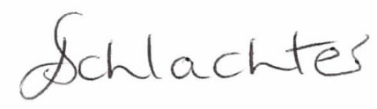
Gabrielle Gant | Commercial Manager | 

*HARA Team Leader

CONTRIBUTIONS AND EXPERTISE EACH TEAM MEMBER BRINGS TO THE RISK TEAM
CE Schlachter | - 37 years in manufacturing environment.  - Exposure to Management Systems i.e. ISO 9000, ISO 14000, ISO 18000, TS16949.  - Good relation skills  - Human Resources background.  - HACCP Training received  - 10 years’ experience in the packaging industry  - Formal Root Cause Analysis Training
ME Schlachter* | - Raw material procurements,  - Technical aspects relating to the product,  - Quality issues that may affect the product  - Production Process.  - Systematic  - Financial background.  - Formal HACCP training received  - 12 years’ experience in the packaging industry  - Formal training on BRC Global Standard for Packaging and Packaging Material  - Formal Root Cause Analysis Training  - Strong hands-on Team in the Factory environment.
L Schlachter | - Very systematic  - Detail focus  - Computer Literate.  - Managing logistic and services agreement  - Formal HACCP training received  - 12 years’ experience in the packaging industry
G Gant | - Qualified Charted Accountant having extensive experience in a financial audit environment and different industry sectors.  - Very systematic  - Detail focus  - Computer Literate  - Planning Process  - Performs traceability of raw material and finished goods function.  - Formal HACCP training received  - 7 years’ experience in the packaging industry  - Formal training on BRC Global Standard for Packaging and Packaging Material  - Formal Root Cause Analysis Training

HARA STUDY PRODUCT DESCRIPTION
TERMS OF REFERENCE

Product Name / Study Title:
- Conversion of various flexible films into pouches, namely Stand-Up Pouches, Flat Pouches and Spouted Pouches.
- Slitting & Rewinding of various reels of Film for the eventual conversion into pouches.

Terms of Reference / Scope of Study:
Scope:
The conversion of printed and plain flexible laminates (PET/LLDPE, BO Nylon/LLDPE) and metallised plastic laminates (MET PET/LLDPE) into stand-up (doy-packs), folded gusseted, 3-side seal, quad seal and spout pouches for food, beverage, personal care and industrial applications.

Slitting and rewinding various raw material reels of film for the eventual use as raw material on the Pouch Making Machines as stated above.

Objective:
To ensure a multidisciplinary Hazard Analysis and Risk Assessment team is in place to develop and manage the hazard and risk analysis system and ensure this is fully implemented and evaluated for its effectiveness.
To implement and maintain a formal Hazard Analysis and Risk Assessment system to ensure that all hazards to product safety, quality and legality are identified and appropriate controls established.

Products:
- Stand-up pouches (doy-pouches)
- Flat pouches
- Spout pouches
- Quad seal pouches
Hazards considered:
- Microbiological Hazards
  - Hand Wash Basin at entrance of Factory.
  - Bacterial contamination risk from cooler bars leaking.
  - Water contamination from cooling system is considered as it is a closed cycle and the water may come into contact with the product if leaking due to being broken.
        - Planned Maintenance to prevent potential risk to Product Safety from any leaks at connections/fitting of pipes.

  - Microbiological hazards that may impact product safety of raw materials of finished goods at the Slitting Department

- Foreign Objects;
  - Temporary modifications are considered where product safety and quality is at risk.
  - Foreign Body Contamination that may impact product safety of raw materials at the Slitting Department
  - The workshop is included in the Site Schematic and potential foreign body contamination is controlled by swarf mats and the workshop door being closed at all times. ‘Clean as you go Policy in place’. Training given to employees.
  - Potential Risks introduced from the building structure are considered under foreign objects and preventative measures include Site Standard procedure, housekeeping and cleaning procedure as well as the storage procedure.
  - Malfunctioning equipment was considered as a risk however there are checks in place at required frequency during production of the products to ensure that equipment that may pose a risk to product safety and quality if this equipment malfunctions are identified and rectified. Preventive measures include process control, a maintenance procedure & a control of non-conforming procedure.
  - These include:
Back Gusset Punch punching correctly
Condition of Teflon.
Condition of Rubber Draw Rollers
- Core dust and debris from the core is considered a Foreign Body Hazard. Housekeeping and Cleaning in place. Clean as you go. Trained employees. Covered product in stores.

- Chemical Contamination:
  - Potential for unintended migration of substances from the packaging material into food or other hygiene sensitive products.
  - Chemical contamination risk from chiller bar leaking.
  - Chemical contamination risk that may impact product safety of raw materials of finished goods at the Slitting Department
  - Water contamination from cooling system is considered as it is a closed cycle and the water may come into contact with the product if leaking due to being broken.
        - Planned Maintenance to prevent potential risk to Product Safety from any leaks at connections/fitting of pipes.

- Quality:
  - Defects critical to consumer safety
  - Hazards that may have an impact on the functional integrity and performance of the final product in use.
  - Hazards that may impact quality of raw materials of finished goods of finished goods at the Slitting Department
  - Potential for malicious
  - Potential for fraud (e.g. substitution, adulteration or misrepresentation)
  - Foreseeable misuse by the consumer.
  - Potential for raw material fraud.
  - Bright lights above machinery to ensure proper visuals of products taken place. – Lights are covered.
  - Malfunctioning equipment was considered as a risk however there are checks in place at required frequency during production of the products to ensure that equipment that may pose a risk to product safety and quality if this equipment malfunctions are identified and rectified. Preventive measures include process control, a maintenance procedure & a control of non-conforming procedure.
- These include:
      - Condition of Sealer Bars
      - Condition of Rubber Silicon Pads
      - Condition of Teflon.

- Other Hazards and Information :

  - Potential problems arising from the use of with recycled materials content are not considered as recycled materials are not used.
  - Legal criteria and Historical Hazards are addressed in the hazard categories depicted above.
  - The allergens that were only considered is allergens that may be present in the machine maintenance lubricants & cleaning products however no allergen is present as stated in declaration from Suppliers.
  - No Printing is done on site.
  - Based on the Hazard Analysis and Risk assessment (HARA) performed below, no in-line testing and measuring equipment was deemed necessary for the manufacture of products, as manual quality checks are performed off line mitigating the quality and product safety risks.
  - Subcontracting processes are not considered as there are no subcontracted processes.

Starting point:
- Supplier Approval
End Point:
- Customer Returns

Process Control
To ensure awareness of the potential for any aspect of the process to go out of control, and to have mitigating measures in place the following hazards are considered:
• Product quality defect
• Defects that may have an impact on the functional integrity and performance of the final product in use.
• Defects which result in the production of products which are outside customer-specified quality parameters.

PRODUCTS DESCRIPTIONS AND THEIR INTENDED USE.

End Product Characteristics:
- Sealed laminated PET film to LLDPE and/or laminated BO Nylon film to LLDPE varying in gauge pouches.
- Safe for the use in Food & Beverage, Industrial, Personal Care and Pharmaceutical industries.
- Utilised for liquid and dry products that may be sensitive to UV exposure.
- Re-sealable.
- Spout fitment.

Reasonably intended use of product:
- Packaging of liquid and dry products.
- Safe for the use in use in Food & Beverage, Industrial, Personal Care Pharmaceutical & Pet Care applications.

Defined restrictions on use:
- Product packed under high heat or steam conditions should be done so with caution.
- Product cannot be used to hold food during cooking.
- Product with high acidity should be monitored after packing.
- Products with MET PET construction is best suited for dry goods.
- Unprinted products should be utilized within one (1) year of receipt.
- Printed products should be utilized within six (6) months of receipt.
- Resealable Zipper cannot be used ultimately for sealing the product during distribution and retail phase. Heat seal must be applied above zipper.
Any unintended but reasonably expected mishandling and misuse of end product:
Misuse | Consequential Hazard / Quality/Process Defect | Preventive Measure
Incorrect storage | Permeability, Visual, Moisture vapour transfer rate, Integrity  Functionality. Contaminated Product: Pest & Foreign Objects | Information included on the Pouch Specification form & COC.  Product packed into liner before corrugate to reduce contamination.  Palletised with Slip Sheet to ensure wood chips, dirt from ground and/or other foreign objects are not getting into product.
Incorrect application | Delamination, Permeability &  Leaking | Information included on the Pouch Specification form & COC
Handling and transportation | Damaged product  Contaminated product:  Pest & Foreign Objects  Leaking Product due to the utilisation of zipper as the final seal once product is packed. | Product packed into liner before corrugate.  Palletised with Slip Sheet  Pallet Wrapped with shrink Wrap. Vehicle Inspections done with own delivery vehicle & 3rd party transportation companies. (SLA in place)  Adequate final seal to ensure no leaking through the zipper or otherwise in the trade.

Target group:
- Food & Beverage Industry
- Pharmaceutical Industry
- Cosmetics Industry
- Industrial Manufactures.
- Pet Industry – Petconomy

Type of Packaging:
- Plastic Liners
- Corrugate
- Self-Adhesive Tape (Buff Tape)
- Self-Adhesive Label
- Slip sheet
- Pallets
- Shrink Wrap
- Angle Board for Pallets, if applicable.

Shelf life, including storage temperature:
- Ideal Storage Conditions: 5 – 35 ºC
- Dry, enclosed environment.
- Unprinted Pouches should be utilized within one (1) year of receipt and printed pouches should be utilised within six (6) months of receipt.
- Printed products should be utilized within six (6) months of receipt.

Where will it be sold: i.e. retailing, further processing etc.
- Further processing
- Wholesaler
- Distributors

Labelling instructions:
- Customer
- Product Code
- Description
- Work Order Number
- Carton Number
- Carton Quantity
- Weight
- Operator/Packer Initial

Blue label – Intermediate Products (WIP)
Orange labels – Non-Standard Quantity
Red labels – Hold for Segregated Non-Conforming Product.

Special distribution control: i.e. Shipping conditions, Methods of Distribution
- Road transport (max. 1 pallet stacking)
- Hygienic
- Dry storage conditions
- Enclosed / protected
- Traceable (labelling)
- SLAs in place with 3rd party transport companies.

Traceability Sequence: Raw Material to finished Goods and vice versa e.g. Purchase Order No Batch No, Date code
- Raw Material Specifications (Material Data Sheets)
- Purchase Order / Slitting Patterns
- Supplier Delivery Note
- Supplier COC
- Supplier Reel Number/s
- Supplier Work Order Number/s
- Supplier Reel Weight
- Slitting Machine Work Order Number
  - Production Log Sheet (Slitting Machine)
  - Finished Reels (Raw Materials) number/s on labels (Slitting Machine)
- Pouch Makers Work Order Number
  - Production log sheet (Short Interval Control) (Pouch Makers)
  - Finished Product or Work in Process Carton number/s on labels.
- Spout Machines Work Order Number
  - Production Log Sheet (Spout inserter Machine)
  - Finished Goods Carton Number/s on Labels
- Return to Stores Labels with above details – Raw Material, WIP & Finished Goods.
- Picking Slips
- Delivery Note
- COC (if applicable to customer requirement)
- Tax Invoice
- Customer Delivery Note

Treatments and Processes Undertaken
Product scope: Laminated plastic pouches (stand-up/flat), with and without resealable zippers; optional spout and cap assembly. Laminate webs are printed by approved external printers (see Artwork/Print control). No post-consumer recycled content is used in finished products.

Process summary (in order).

- Artwork/Print approval: Customer-approved artwork → printer “on-press approval” (OPA) and signed first-offs → printed laminate supplied to site.
- Incoming material receipt & ID: Films, zippers, spouts/caps, carton liners received, labelled, and verified to spec before release.
- Slitting (where applicable): Reels slit to width per Job Card.
- Pouch Making: heat sealing, zipper application/seal, cosmetic features (punches) where specified.
- Process Control—short interval control: Pre-start checks, first-off samples each shift, short-interval control, and documented line clearance at startup and completion.
  - Short Interval Controls: As per Work Instruction for Quality Checks.
- Work-in-progress control: Formed pouches held as WIP in blue-label cartons with full traceability.
- Spout inserting (MDB): Spout placement and sealing to pre-formed pouches.
  - Short Interval Controls: As per Work Instruction for Quality Checks
- Pack, label, and release: Quantity Document, finished goods carton labels with WO and carton numbers, quantity, and packer initials; Certificate of Conformance issued where required.
- Storage & Distributioon: Controlled storage; distribution per picking slip/delivery note; records retained.

Key treatments/controls by step.

Step | Treatment / Operation | Typical Controls & Records
Printing (Supplier) | Printed Pouch Checklist | Customer OPA sign-off & 1st-offs filed by printer; internal artwork pack with Job Card.
Slitting | Mechanical cutting to width | Slitting Job Card & Production Log Sheet; visual/measure checks
Pouch Making | Heat sealing (side/bottom), punching (euro slot/tear nick), zipper sealing | Job Card process specs; pre-start checks; first-off/retained samples; interval checks; Production Log Sheet
Spout inserting | Thermal sealing of spout fitment. | MDB Job Card & Log Sheet; first-off/retained samples; leak checks
Work-in-progress control: Formed pouches held as WIP in blue-label cartons with full traceability. | Water/submersion, template, zipper opening force (if specified) | Results on Production Log Sheet: non-conforming product handled per procedure
Line clearance | Physical removal/cleaning and verification at changeovers | Recorded on Production Log Sheet; supervisor sign-off before restart
Identification & traceability | Raw material → WIP (blue label) → finished goods carton labels → NC Product (RED label segregated) | Label controls; WO/carton numbers; Job Cards; Production Log Sheets; COC where applicable

Records used. Customer-approved artwork pack; Job Cards (pouch, MDB, slitting); Production Log Sheets; first-off/retained samples attached to Log Sheets; WIP blue-label cartons; finished goods carton labels; Certificates of Conformance (when required).

Rework. Any rework remains uniquely identifiable and traceable to the original batch and is processed under the same controls as above.

Verification. The HARA flow diagram includes the process flow and is verified during HARA review and internal audits (including annual traceability tests). Line clearance and first-off/interval checks verify that treatment parameters and product dimensions remain within specification.

Functional Properties — Cross-Variant Control (Applies to All SKUs)
Principle: Functional properties for every SKU are controlled by the approved product specification and, where applicable, customer-specific requirements. This HARA section defines the common property set and the standard verification methods. Numeric targets/tolerances are not duplicated here; they are taken from the current, approved specification for the variant or customer contract.

Functional property (all variants) | Why it matters (risk) | Acceptance source (per SKU) | Verification & frequency (standard) | Records
Barrier performance (e.g., OTR/WVTR) (where specified) | Shelf-life; oxidation/taint | Pouch specifications, supplier CoC/test data, customer spec | At material approval; periodic supplier data review; targeted third-party testing if required | Material approval pack; supplier CoC/test reports; HACCP/spec review notes
Seal integrity (side/bottom seams) | Leakage/contamination | Pouch specifications | First-off each run/shift; in-process interval checks; leak tests where specified | Production Log Sheet; first-off/retained samples; NC/CA records
Zipper function (opening/closing force) (zipper SKUs only) | Resealability & adhesion integrity | Pouch specifications | First-off; interval checks | Production Log Sheet; first-off samples
Spout seal integrity & cap fit (spout SKUs only) | Leakage; hygiene; safety | Pouch specifications / WI | First-off & interval leak checks; visual/fit/torque checks as specified | MDB Log Sheet; first-off/retained samples
Dimensions & feature positions (H, W, gusset; tear-nicks; euro slot; zipper set-back) | Fill volume, consumer use | Pouch specifications | First-off; interval checks; template/gauges | Production Log Sheet; first-off sample attached
Mechanical robustness (if specified) | Transit/handling damage | Pouch specifications or customer spec | As per spec/test plan (per batch/periodic) | Production Log Sheet; test reports
Material suitability/chemical compatibility | Swelling, delamination, taint | Pouch specifications; supplier declarations; legislation refs | Review at approval/change; application checks if needed | Material approval pack; DoC/CoC
Temperature constraints (filling/use/storage) | Seal creep; distortion | Pouch specifications | Pre-dispatch spec confirmation; customer brief | Pouch specifications; order confirmation
Migration/food-contact compliance | Legal compliance | Supplier DoC/CoC; 5.1F1 | Doc review at approval and spec review | Compliance file; Pouch specifications
Taint/odour. | Sensory acceptability | Pouch specifications /material DoC | As application/customer requires; complaint trend review | Complaints Register; CAPA
Print/appearance (printed SKUs) | Branding; legibility, hidden allergens. | Artwork pack; printer OPA first-offs | Artwork approval; OPA sign-off; incoming visual | Artwork pack; printer 1st-offs
Packout/pallet stability | Damage in distribution | Pack method | Visual check at pack/dispatch | Dispatch checks; picking/dispatch records
Usable life of packaging | Performance over time | Pouch specifications | FIFO/FEFO; condition checks | Warehouse logs; Pouch specifications

SENSITIVE RAW MATERIAL DECISION TREE

SENSITIVE RAW MATERIAL ANALYSIS
Raw Material /  Packaging Material Description | How is it packaged on arrival | Where does it come from | Key Specification requirements | Hazards / quality defects that may be present in this raw material | List Hazards that may be present in this raw material | Special storage conditions | Does this material contain any allergens? | Will the material deteriorate if not stored correctly? | Is the Material susceptible to Mycotoxins? | Is the Material susceptible to pathogens? | Q1 | Q2 | Q3 | SRM (Sensitive Raw Material) | Remarks
Film: Non-Trademarked Reel Stock.  Film: Printed Trade Marked Reel Stock  (See Raw Material Specification Register) | Shrink wrap / wrapped in clear poly and palletized, and cord strap with Slip Sheets | Refer to Supplier Risk Assessment. | Refer to Raw Material Data Sheets. | Microbiological | None | Slip Sheets utilised for storage & transportation of material.  Poly Plank Pallets on site.  Materials Stored in separate area, Raw Materials stores inside factory. | No | Yes | No | No | No | - | - | No | Supplier BRC/FDA certificated.  Personnel hygiene policy in place at Supplier.
 |  |  |  | Foreign Objects | Pests; wood chips from damaged pallets during transportation. Insects/Pests present in the material from production process of supplier. Loose blades/cutters from suppliers. |  |  |  |  |  | Yes | Yes | No | No | Supplier BRC/FDA certificated.  Incoming Raw Material Inspection completed.  Vehicle inspection taken place at raw material supplier.
 |  |  |  | Chemical | Non- Food grade Inks for Printed Reel Stock  Potential for unintended migration of substances into food or other hygiene sensitive product. |  |  |  |  |  | Yes | Yes | No | No | Supplier BRC/FDA certificated.  Declaration from Supplier.  Vehicle Inspection taken place at raw material supplier as seen on copy of supplier delivery note.  Chemical contaminations not possible as chemicals are secure & isolated on site.  Analysis of film & migration report from Supplier.  Limitations of use on both Pouch Spec. Form and CoC
 |  |  |  | Quality | Incorrect Specifications  Trademark Infringements  Hidden Allergens, Misleading Labels  Ink Splash  Delamination  Clarity of Material  Creases in material. |  |  |  |  |  | Yes | Yes | No | No | Supplier BRC/FDA certificated.  CoC verification with delivery note & specifications.  Customer signed Pouch Spec Form before placement of order for Raw Material.  Customer signs off artwork proof before plates are made for printing.  NCAs raised on Suppliers and for continuous improvements.  Based on disposition on NCA will determined if NC Product is returned to Supplier.
Zipper | Liners & corrugated  carton together with batch number and opening strength label | Refer to approved suppliers list | Refer to Raw Material specification register | Microbiological | None | No | No | No | No | No | No | - | - | - | None
 |  |  |  | Foreign Objects | Splicing tape from zipper join may be present in box. Insects/Pests present in the material from production process of supplier. |  |  |  |  |  | Yes | Yes | No | No | Splicing tape used is coloured so that it can be noticed by operator at short interval control.  Cartons are glued as staples are not permitted in factory.
 |  |  |  | Chemical | None |  |  |  |  |  | No | - | - | - | No chemicals used in the manufacture of this product.
 |  |  |  | Quality | Incorrect specification: Incorrect size & opening force supplied. |  |  |  |  |  | Yes | Yes | No | No | On placement of order size and strength is stated. Colour markings on cartons by supplier make easy identification for issue to production.  COC received.  NCAs raised on Suppliers and for continuous improvements.  Based on disposition on NCA will determined if NC Product is returned to Supplier
Spout & Cap | Liners & corrugated  carton together with batch number | Refer to approved suppliers list | Refer to Raw Material specification register | Microbiological | None | No | No | No | No | No | No | - | - | - | None
Spout & Cap | Liners & corrugated  carton together with batch number |  |  | Foreign Objects | Pests; wood chips from damaged pallets during transportation. Insects/Pests present in the material from production process of supplier. Loose blades/cutters from suppliers. |  |  |  |  |  | Yes | Yes | No | No | Incoming Raw Material Inspection completed.  Supplier certification.
Spout & Cap | Liners & corrugated  carton together with batch number |  |  | Chemical | None |  |  |  |  |  | No | - | - | -
Spout & Cap | Liners & corrugated  carton together with batch number |  |  | Quality | Incorrect specification |  |  |  |  |  | Yes | Yes | No | No | Supplier certified.  Product Specs in place.  COC with each delivery  Incoming inspection on each delivery,  NCAs raised on Suppliers and for continuous improvements.  Based on disposition on NCA will determined if NC Product is returned to Supplier
Virgin Blue Plastic liners | Wrapped in Poly with quantity label. | Refer to approved suppliers list | Refer to Raw Material specification register | Microbiological | None | No | No | No | No | No | No | - | - | No | None
 |  |  |  | Foreign Objects | None |  |  |  |  |  | No | - | - | No | Visual Inspection at utilization of liner.
 |  |  |  | Chemical | None |  |  |  |  |  | No | - | - | No | No Chemicals are used in production of liners.
 |  |  |  | Quality | None |  |  |  |  |  | No | - | - | No | Declaration form Supplier.  NCAs raised on Suppliers and for continuous improvements.  Based on disposition on NCA will determined if NC Product is returned to Supplier
Splicing tape | Corrugated & shrink sealed | Refer to approved suppliers list | Refer to Raw Material specification register | Microbiological | None | No | No | No | No | No | No | - | - | No | Visual Inspections  Non-Traceable Item
 |  |  |  | Foreign Objects | None |  |  |  |  |  | No | - | - | No | Visual Inspections  Non-Traceable Item
 |  |  |  | Chemical | None |  |  |  |  |  | No | - | - | No | Visual Inspections  Non-Traceable Item
 |  |  |  | Quality | None |  |  |  |  |  | No | - | - | No | Visual Inspections  Non-Traceable Item
Corrugated cartons | Palletized with cord strap. | Refer to approved suppliers list | Refer to Raw Material specification register | Microbiological | None | No | No | No | No | No | No | - | - | No | Visual Inspections  Non-Traceable Item
 |  |  |  | Foreign Objects | None |  |  |  |  |  | No | - | - | No | Visual Inspections  Non-Traceable Item
 |  |  |  | Chemical | None |  |  |  |  |  | No | - | - | No | Visual Inspections  Non-Traceable Item
 |  |  |  | Quality | None |  |  |  |  |  | No | - | - | No | Visual Inspections  Non-Traceable Item
Pallet Wrap | Poly liners | Refer to approved suppliers list | Refer to Raw Material specification register | Microbiological | None | No | No | No | No | No | No | - | - | No | Visual Inspections  Non-Traceable Item
 |  |  |  | Foreign Objects | None |  |  |  |  |  | No | - | - | No | Visual Inspections  Non-Traceable Item
 |  |  |  | Chemical | None |  |  |  |  |  | No | - | - | No | Visual Inspections  Non-Traceable Item
 |  |  |  | Quality | None |  |  |  |  |  | No | - | - | No | Visual Inspections  Non-Traceable Item

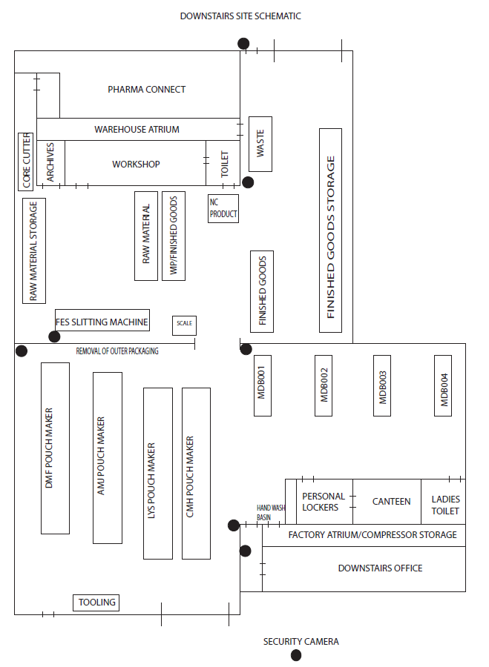
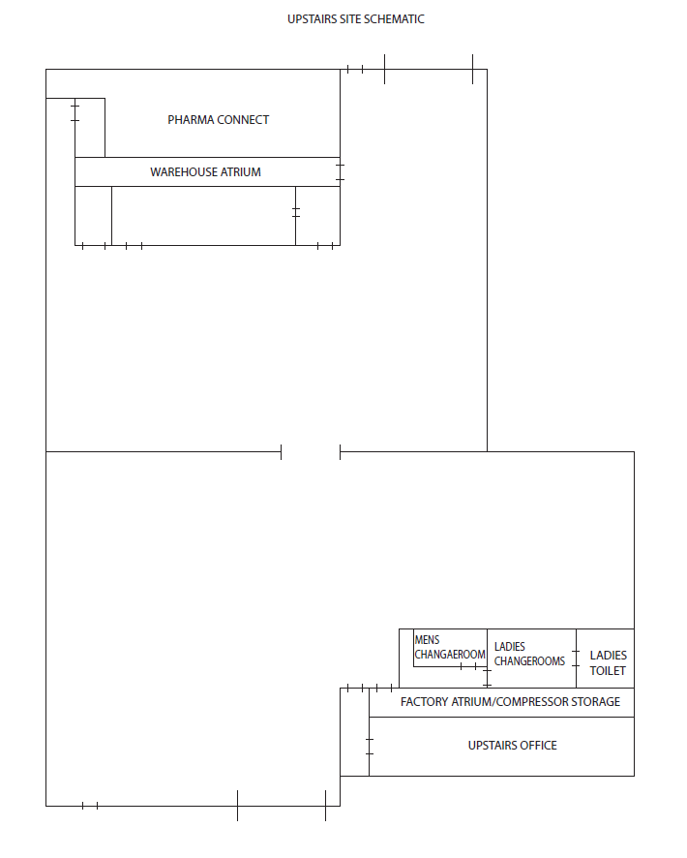

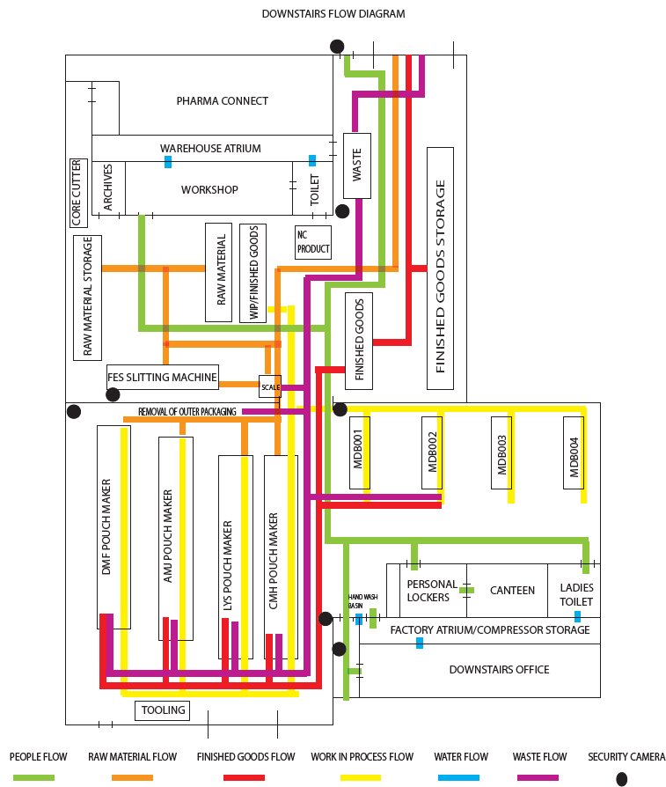

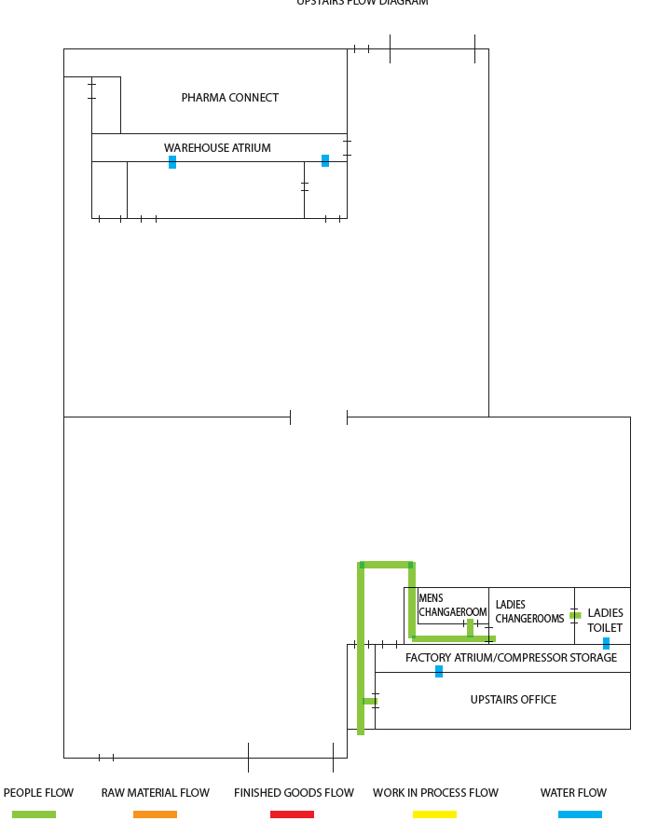

PHYSICAL WALK-THROUGH VERIFICATION PHOTO ANNOTATIONS

Process Flow Verification Evidence

Kangopak (Pty) Ltd
Date of Walk-Through: 30/09/2025
Verification Team: HARA Team
Document Purpose: Evidence of physical walk-through verification per BRCGS Clause 2.4.2

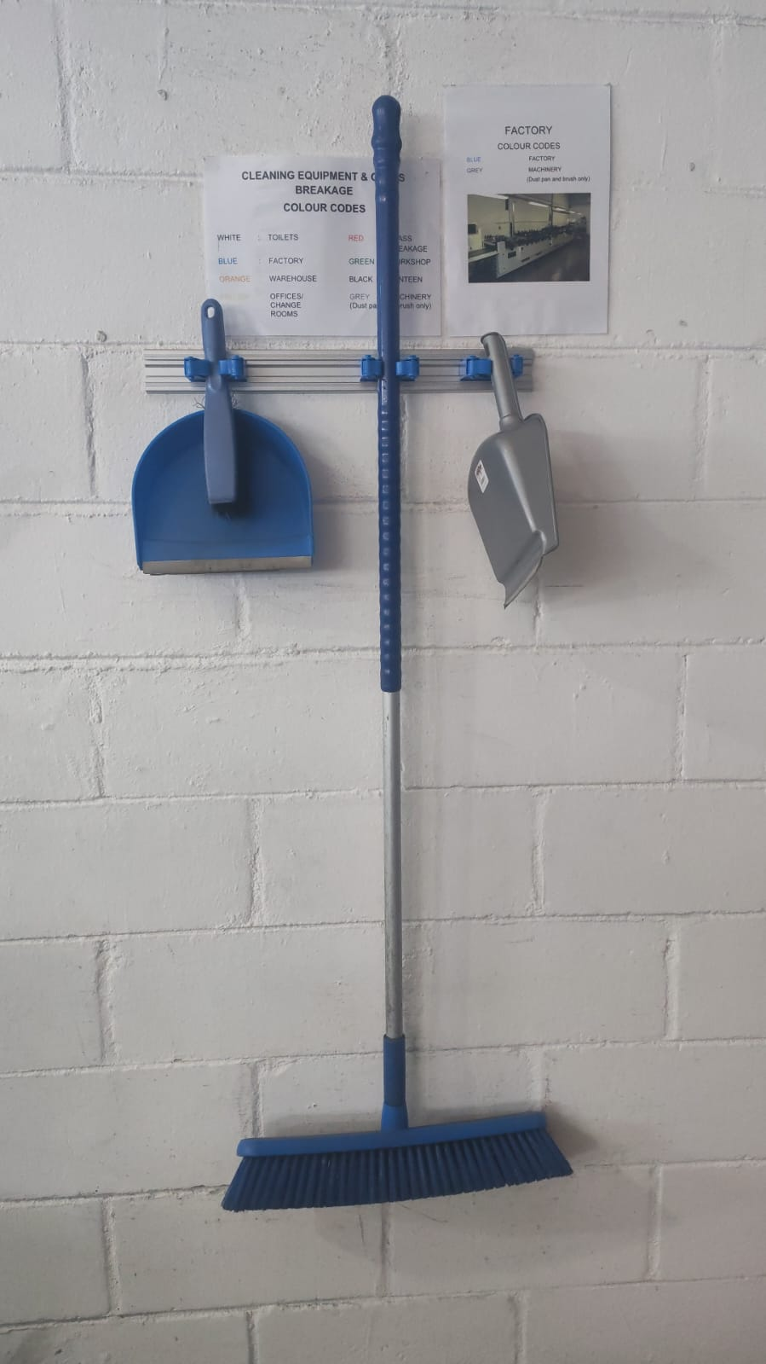
PHOTO 1: CLEANING EQUIPMENT AND BREAKAGE STATION
Location: Factory entrance/cleaning station
Process Step: Hygiene and Foreign Body Control
Time: 1300
Observations:
Equipment Visible:
Blue dustpan and brush for spillage cleanup
Blue broom for floor sweeping
Grey scoop for debris collection

Signage: Cleaning Equipment and Breakage colour codes (White/Blue/Green/Black/Red)
BRCGS Relevance: Demonstrates GMP implementation for foreign body control (Clause 5.8)
Process Flow Verification: Confirms cleaning procedures are in place at production entry point
Deviations: None - matches documented hygiene procedures
Verified: Cleaning station positioned correctly per process flow diagram

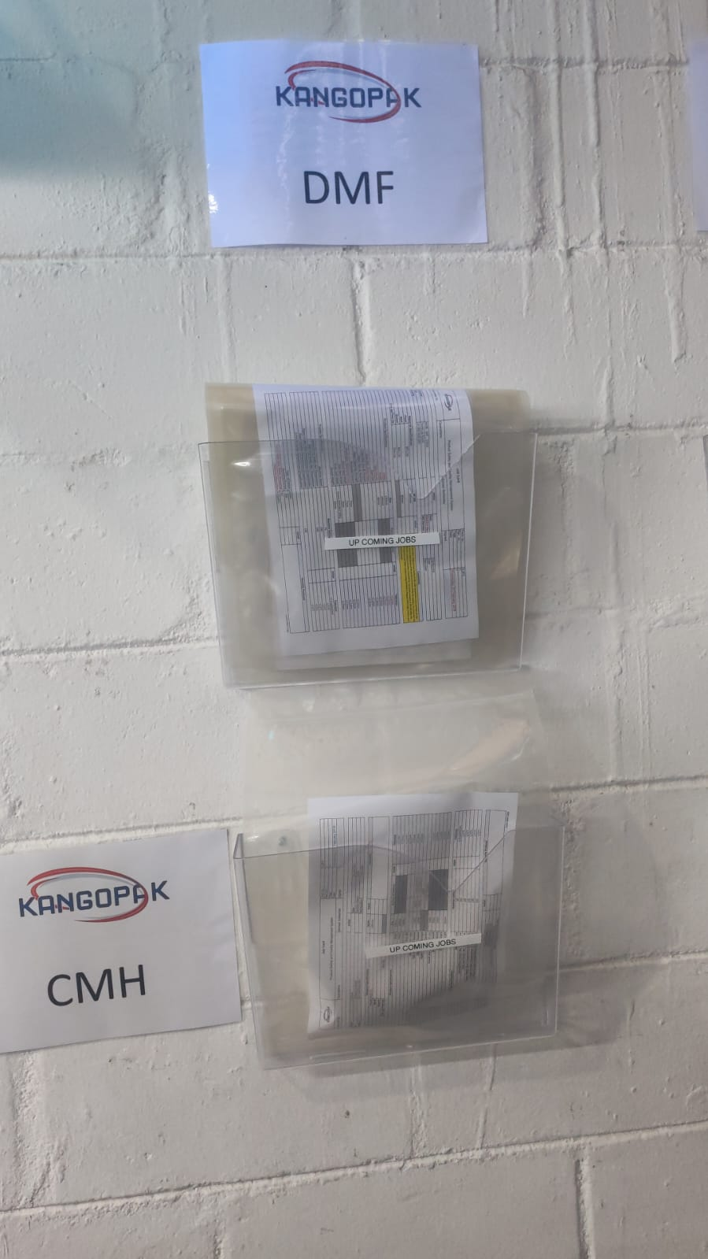

PHOTO 2: MACHINE IDENTIFICATION - DMF AND CMH POUCHING LINES
Location: Production floor - Pouching area
Process Step: Product conversion/pouching
Time: 1300
Observations:
Machine DMF:
Clear machine identification signage
Job pockets/cards visible (showing UP COMING JOBS)
Line clearance documentation holder present
Machine CMH:
Machine properly labelled
Job documentation storage system in place
Clear separation between machines

Work Orders Visible: Multiple job cards showing production planning
BRCGS Relevance: Relates to NC 3 (Line Clearance) - job pockets observed on machines
Process Flow: Confirms pouching lines as per flow diagram
NOTE: Job pockets away from machines - relates to Line Clearance NC 3

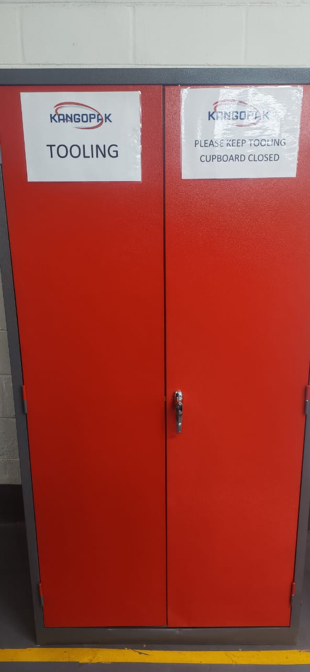

PHOTO 3: TOOLING STORAGE CABINET
Location: Maintenance/tooling area
Process Step: Support function - Maintenance
Time: 1300
Observations:
Storage: Locked red cabinet labeled TOOLING
Security: PLEASE KEEP TOOLING CUPBOARD CLOSED sign
Organization: Controlled access to prevent foreign body contamination
BRCGS Relevance: Tool control for foreign body prevention (Clause 5.8)
Process Flow: Support area properly segregated from production
Verified: Tooling control measures in place

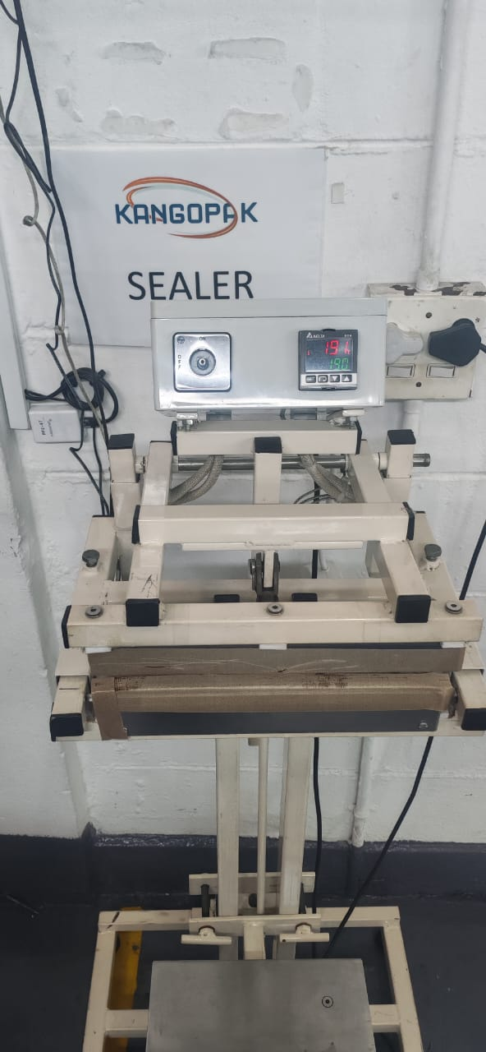

PHOTO 4: SEALER EQUIPMENT
Location: Manual Sealing Station for Quality Testing
Process Step: Pouch sealing operation
Time: 1300
Observations:
Equipment: Kangopak branded sealer with digital controls
Control Panel: Temperature display showing 190 degrees Celsius
Settings: Dwell and temperature controls visible
Condition: Equipment appears clean and well-maintained
Process Flow: Quality step confirmed in production sequence
Operator Station: Foot pedal control visible for operation
Verified: Quality Check operation as per process flow

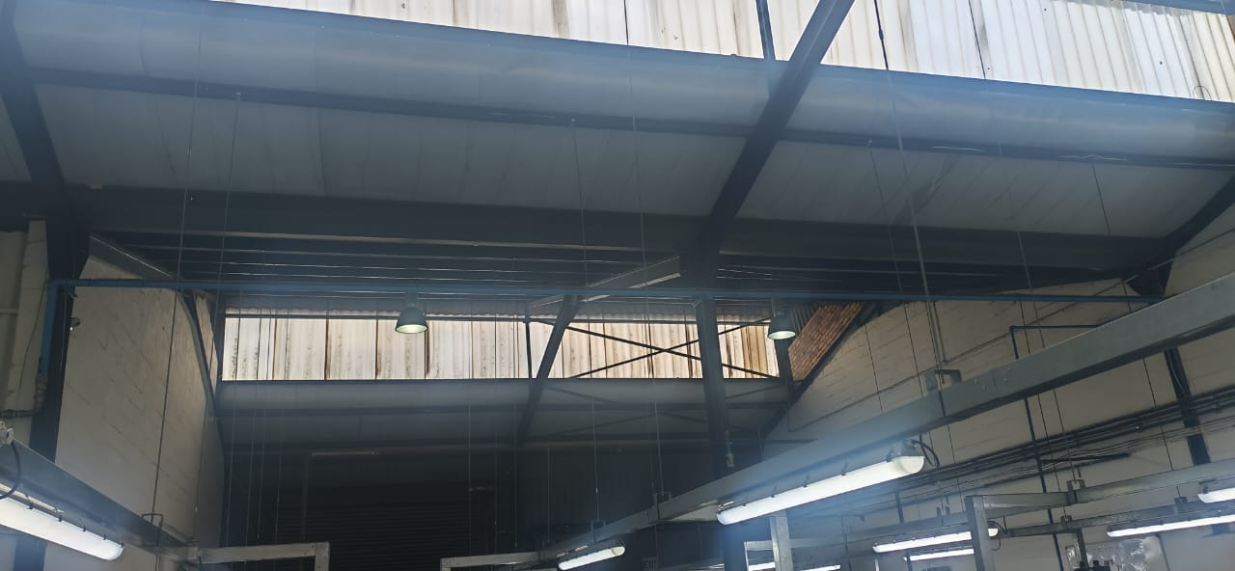

PHOTO 5: OVERHEAD INFRASTRUCTURE - SKYLIGHTS
Location: Production area ceiling
Process Step: Environmental/Infrastructure assessment
Time: 13:30
Observations:
Skylights: Translucent panels visible overhead
Material: Appears to be polycarbonate/Perspex (not glass)
Condition: Intact, no visible damage or cracks
Position: Directly above production area
BRCGS Relevance: CRITICAL - Relates to NC 2 (Skylight hazard assessment)
Risk Assessment: Overhead contamination risk point identified
CRITICAL: Evidence for NC 2 - Skylights present above production

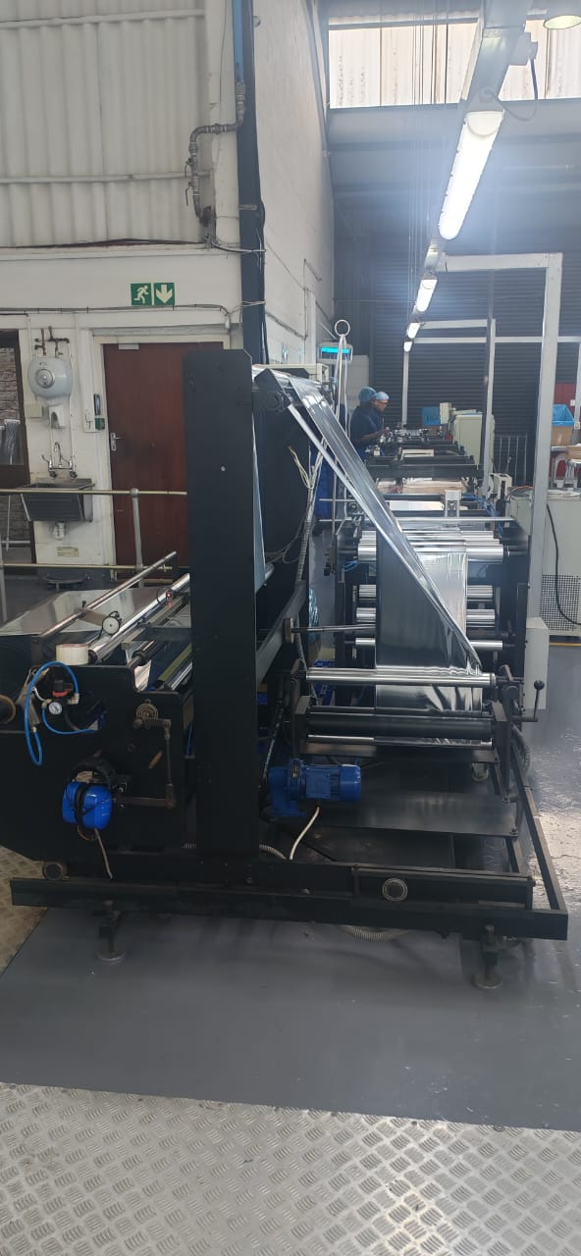

PHOTO 6: PRODUCTION LINE - SLITTING OPERATION
Location: Pouching department – CMH Machine
Process Step: Material conversion – pouch making
Time: 1300
Observations:
Equipment: Industrial pouch making machine
Operation: Actively processing material
Operator: Personnel visible at station (PN & LD)
Emergency Exit: Green exit sign visible
Workflow: Material flow from unwind visible
Verified: Pouch Making operation matches process flow sequence

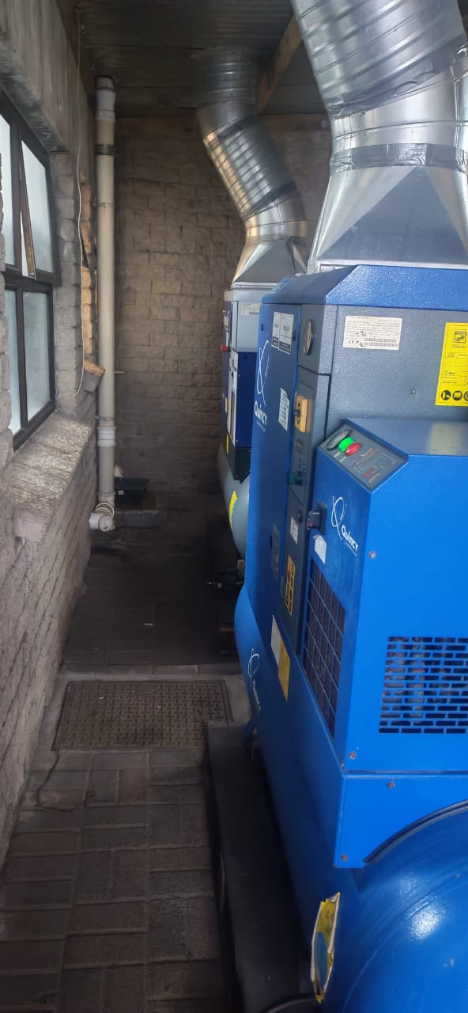

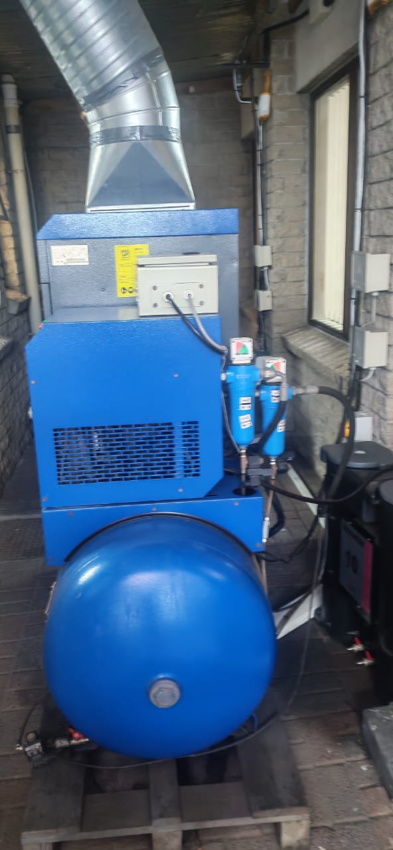

PHOTO 7 AND 8: COMPRESSED AIR SYSTEM
Location: Atrium - Utility Area
Process Step: Support services - Compressed air supply
Time: 13:30
Observations:
Equipment: Blue air compressor unit with tank
Ventilation: Extraction ducting connected
Maintenance: Unit appears well-maintained
Location: Segregated from direct product contact areas
Controls: Pressure gauges and controls visible
BRCGS Relevance: Utility supply for pneumatic operations
Verified: Compressed air system supporting production operations

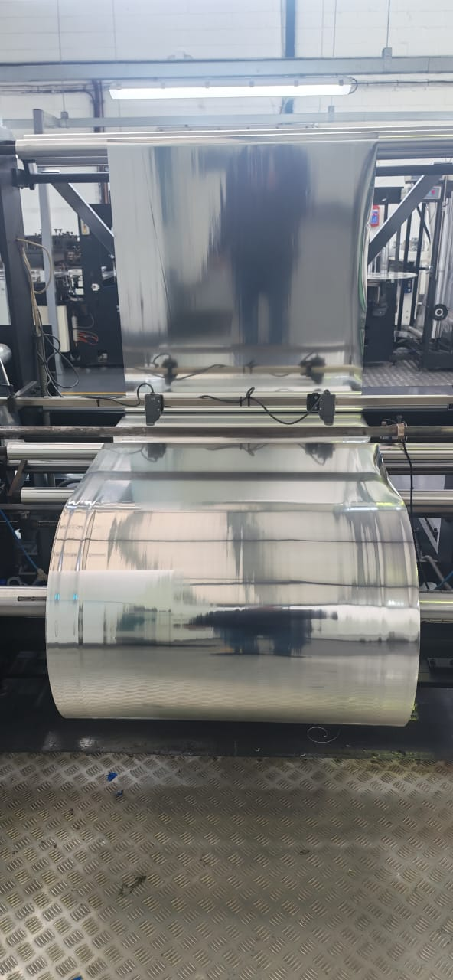

PHOTO 9: RAW MATERIAL ROLL - IN PROCESS
Location: Production floor
Process Step: Load material on machine.
Time: 1300
Observations:
Material: Large roll of flexible packaging material
Stage: Partially unwound, indicating active use
Floor Protection: Anti-fatigue matting visible
Process Flow: Loaded raw material onto pouch making machine
BRCGS Relevance: Material handling and work in progress.
Verified: Material flow and handling procedures

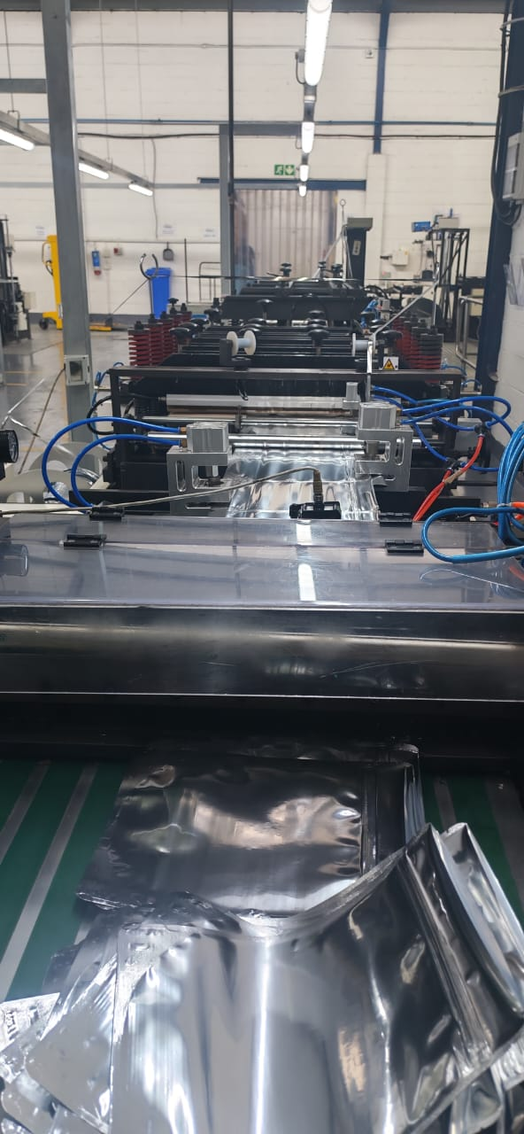
PHOTO 10: POUCH-MAKING LINE DETAIL
Location: Pouching department
Process Step: Final cuts into pouches on pouch maker.
Time: 13:30
Observations:
Equipment: Multi-station pouch-making machine
Operations Visible:
Finished goods being cut into final products
Sealing bars
Forming stations
Pneumatic controls (blue hoses)
Product: Clear pouches being manufactured
Operator Area: Control station visible

Verified: Pouch-making process as documented

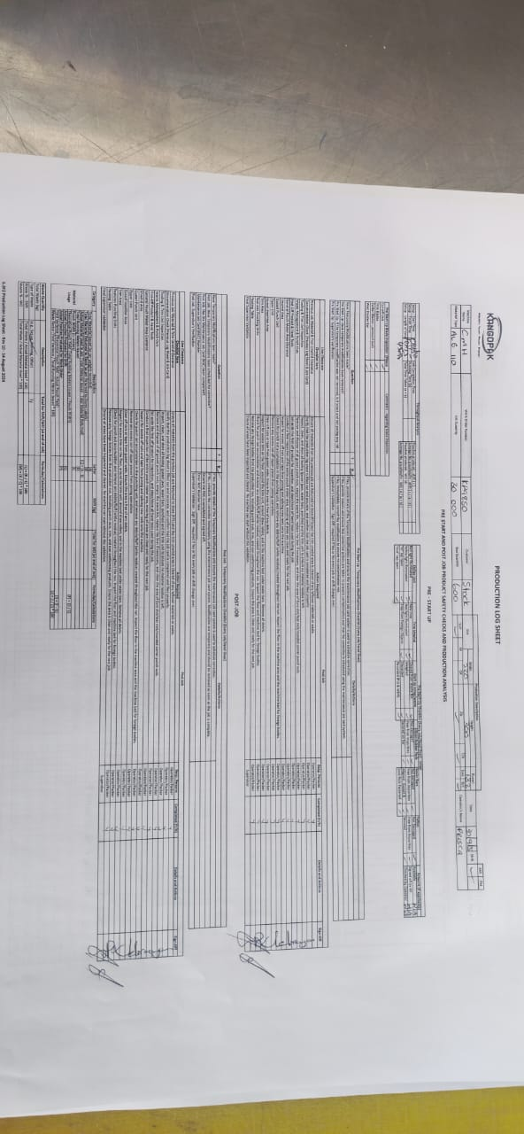

PHOTO 11: PRODUCTION LOG SHEET - OFFICIAL DOCUMENT
Location: Documentation review
Process Step: HARA documentation
Time: 13:40
Observations:
Document: Pouch making production log sheets
Content: pre-startup checklists together with pre-startup line clearances.
Verification: Physical document being used during walk-through
BRCGS Relevance: Critical - Primary evidence document for NC 3
Verified: Production Log Sheet being used for verification and validation for pre-startup checks and line clearance together with post-job line clearance, waste management throughput analysis traceability and quality testing.

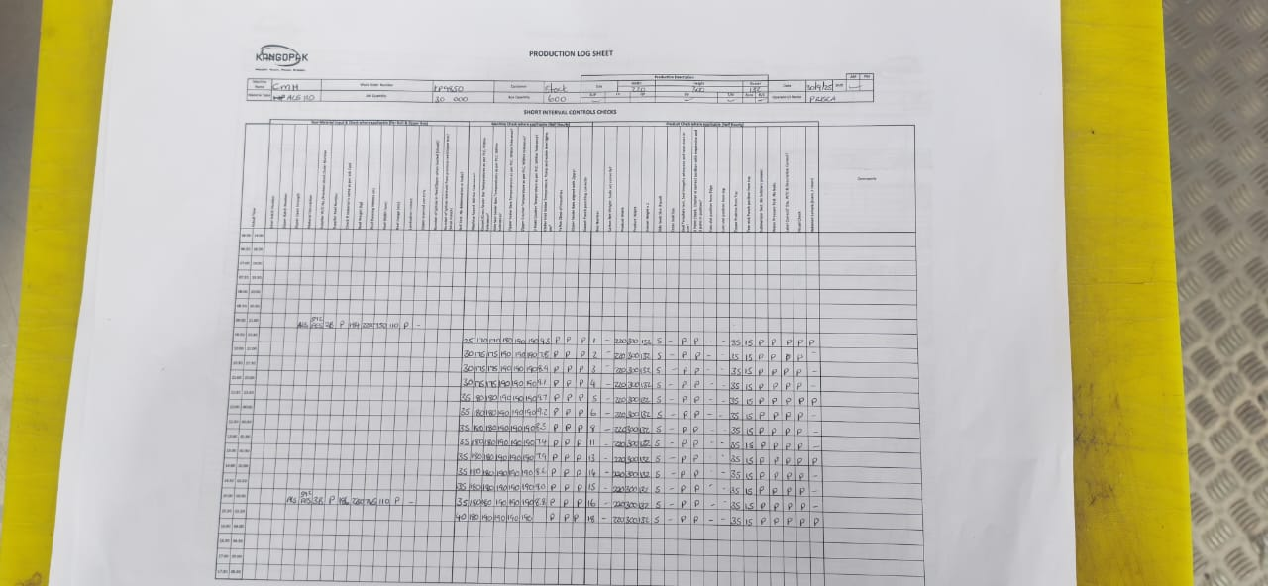
PHOTO 12: PRODUCTION LOG SHEET - OFFICIAL DOCUMENT
Location: Production. Pouch making. CMH machine.
Process Step: Process control - short interval control at predetermined frequencies.
Time: 15:00
Observations:
Document Type: Production Log Sheet
Information Visible: Production schedule grid
Planning: Shows production short interval control sequencing
Control: Evidence of production shorts interval control and quality testing.
Verified: Production Quality Testing and Short Interval Control.

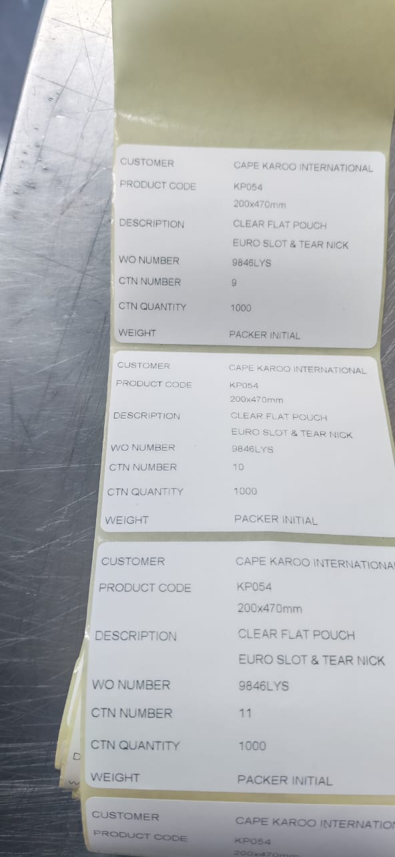

PHOTO 13: FINISH GOOD LABELS - CAPE KAROO INTERNATIONAL
Location: Production floor – LYS Pouch Making Machine
Process Step: Finish Goods packed into cartons.
Time: 13:45
Observations:
Customer: Cape Karoo International
Products:
KP054: Clear Flat Pouch (200x470mm, Euro Slot and Tear Nick)
Work Order: 9846LYS (1000 units)
CTN Numbers: 9, 10, 11 traceability
Weight & Packer Initial present for traceability.
BRCGS Relevance: Evidence of production at time of walk-through traceability and product identification.
Verified: Active work orders during verification & traceability system intact.

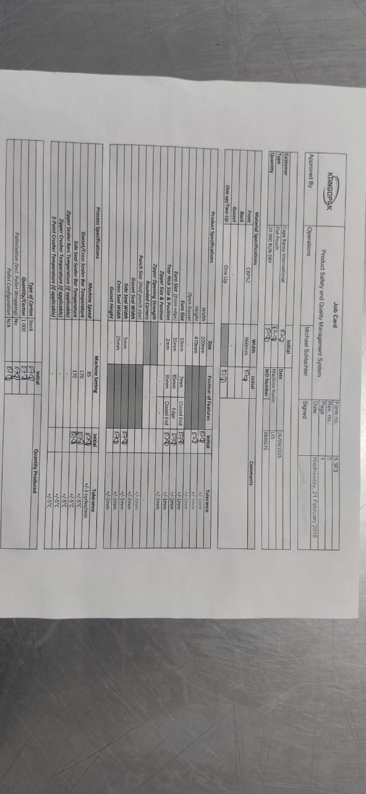
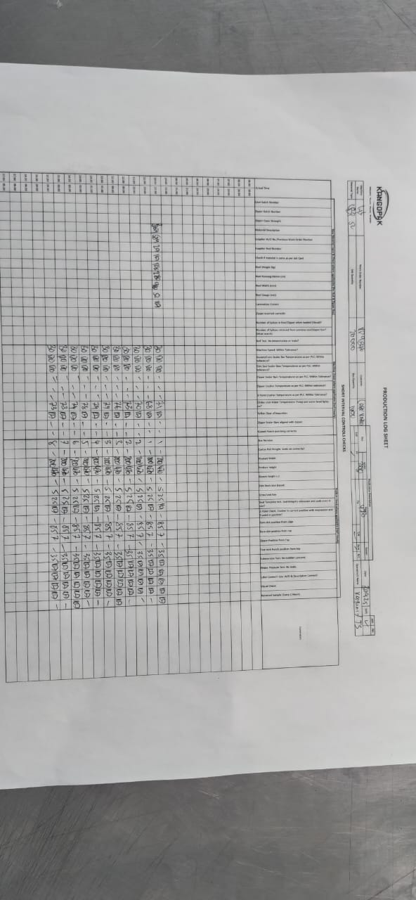

PHOTO 14 AND 15: JOB CARD & PRODUCTION LOG SHEETS DOCUMENTATION
Location: Pouch Making LYS pouch maker
Process Step: Job code generation and issuance. Short interval control
Time: 15:00

Observations:
Documentation: Detailed job cards with specifications and production log sheets.
Tracking: Multiple columns for production tracking, quality tests, raw material inputs, machine checks.
Signatures: Signature blocks visible for verification and accountability.
Control: Specifications, Traceability, Short Interval Control, Equipment Critical To Product Safety, Foreign Body Contamination Control, Control of Non-Conforming Products, Bill Of Materials, Process Specifications, Raw Material Specifications, Work Instruction for Bag making.
Verified: Job control and tracking system

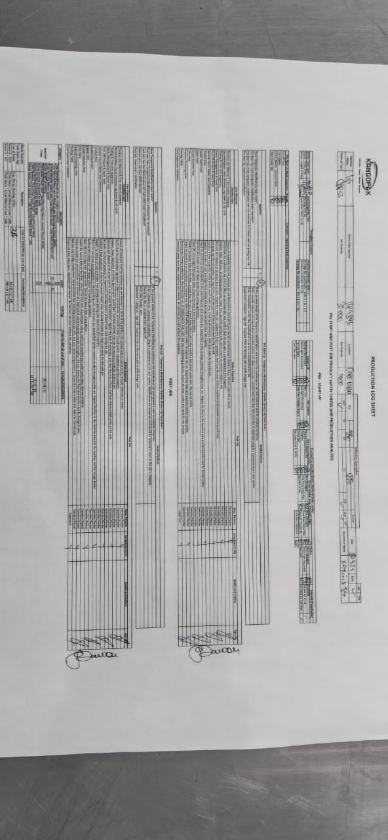

PHOTO 16: PRODUCTION LOG SHEET - OFFICIAL DOCUMENT
Location: Documentation review
Process Step: HARA documentation
Time: 15:05
Observations:
Document: Pouch making production log sheets
Content: pre-startup checklists together with pre-startup line clearances.
Verification: Physical document being used during walk-through
BRCGS Relevance: Critical - Primary evidence document for NC 3
Verified: Production Log Sheet being used for verification and validation for pre-startup checks and line clearance together with post-job line clearance, waste management throughput analysis traceability and quality testing. Traceability. Accountability. Pre-requisite programmes intact.

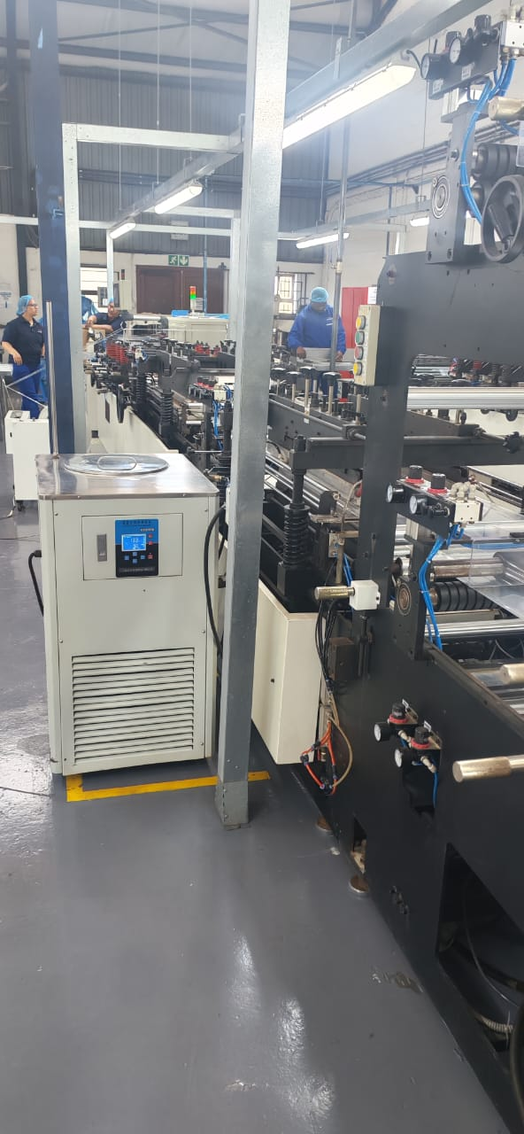

PHOTO 18: PRODUCTION FLOOR - POUCH MAKING DEPARTMENTS
Location: LYS
Process Step: Machine operation
Time: 13:00
Observations:
Operator: Personnel in blue shirt, longs & hair nat (PPE) at workstation
Equipment: Pouch Making Machine (LYS), water chiller unit.
Environment: Clean production environment
Verified: Operator presence at documented stations

PHOTO 19: SLITTING MACHINE - CLOSE VIEW
Location: Slitting department
Process Step: Material slitting
Time: 14:00
Observations:
Equipment: FES slitting machine
Rollers: Multiple guide and tension rollers visible
Material Path: Clear web path through machine
Verified: Slitting process – NC3 finish good storage.

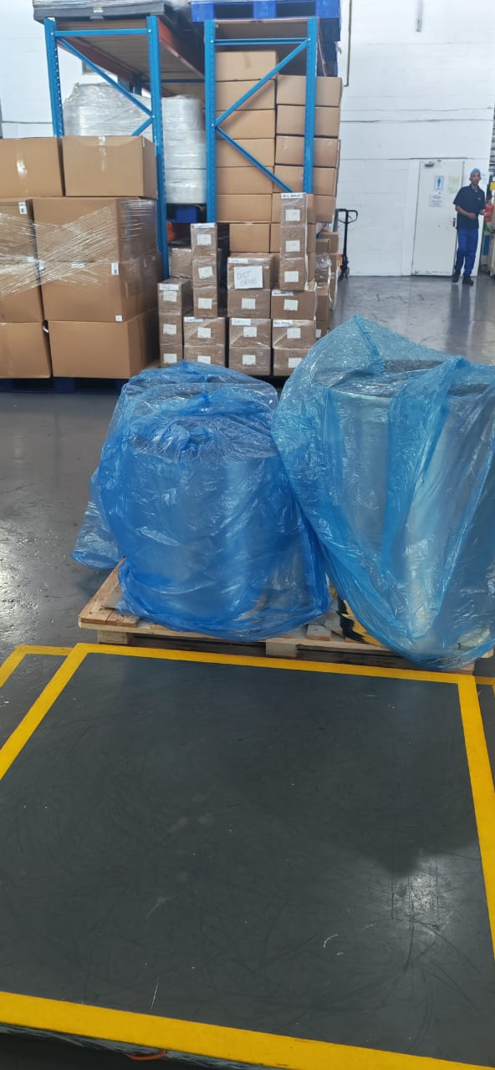
PHOTO 20: COVERED FINISHED GOODS OF THE SLITTING MACHINE
Location: Slitting department in Warehouse (FES)
Process Step: Material receipt and staging
Time: 14:00
Observations:
Materials: Blue-wrapped rolls (protected from contamination)
Storage: Palletized for handling
Warehouse: Clean storage environment
Personnel: Staff member visible for scale
Racking: Organized storage system
Verified: Finished Goods & Raw material storage and protection NC 3

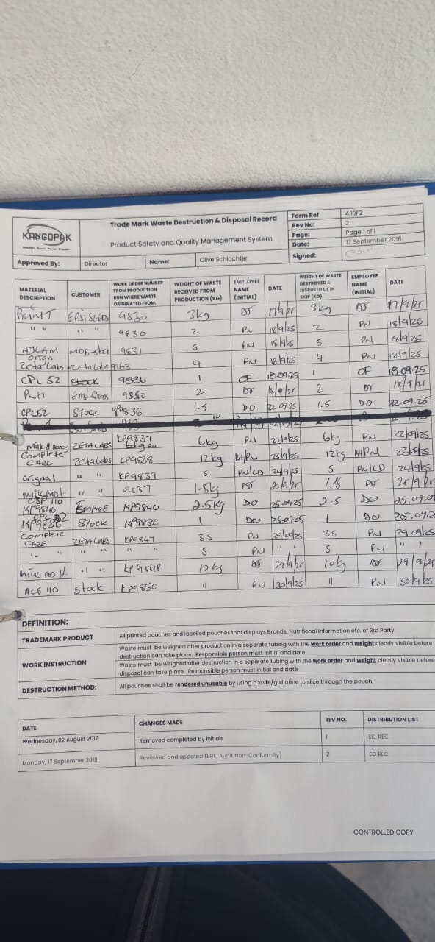
PHOTO 21: TRADE MARKED WASTE DESTRUCTION AND DISPOSAL RECORD
Location: The scale in the warehouse.
Process Step: Waste Management
Time: 14:0
Observations:
Form: Trademark Waste Destruction and Disposal Record
Compliance: Waste tracking documentation
Dates: Multiple entries visible
BRCGS Relevance: Waste Management Procedures (Clause 4.10)
Verified: Waste control documentation

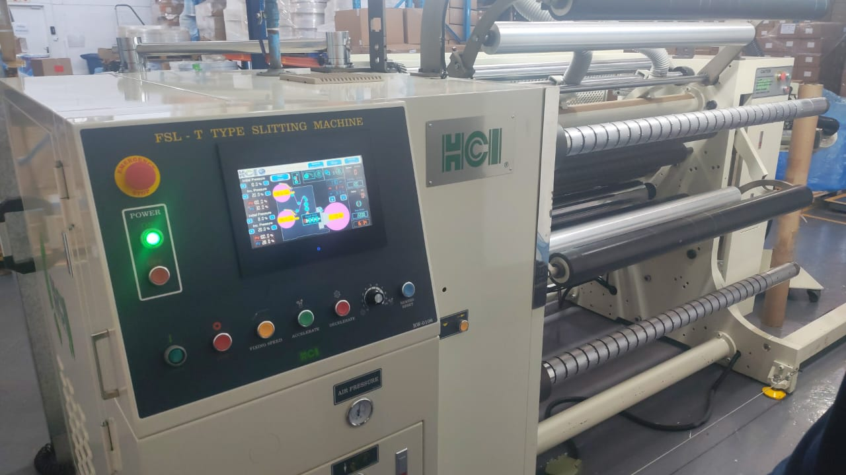

PHOTO 22: SLITTING MACHINE CONTROL PANEL AND REWIND
Location: Slitting department
Process Step: Finish Goods at Slitting Machine (FES)
Time: 14:05
Observations:
Machine: FES - FSL-Y Type Slitting Machine by HCI
Control Panel: Digital display and controls
Operation Buttons: Start/Stop controls visible
Status Indicators: Green operational lights
Verified: Equipment controls and operation

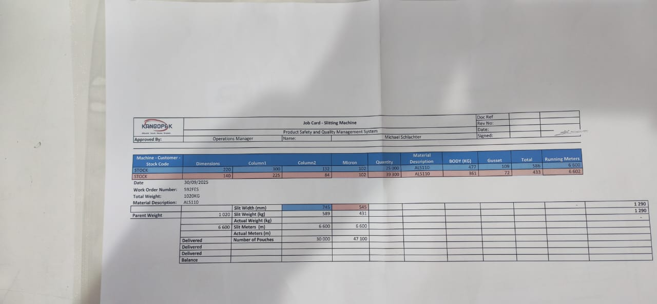

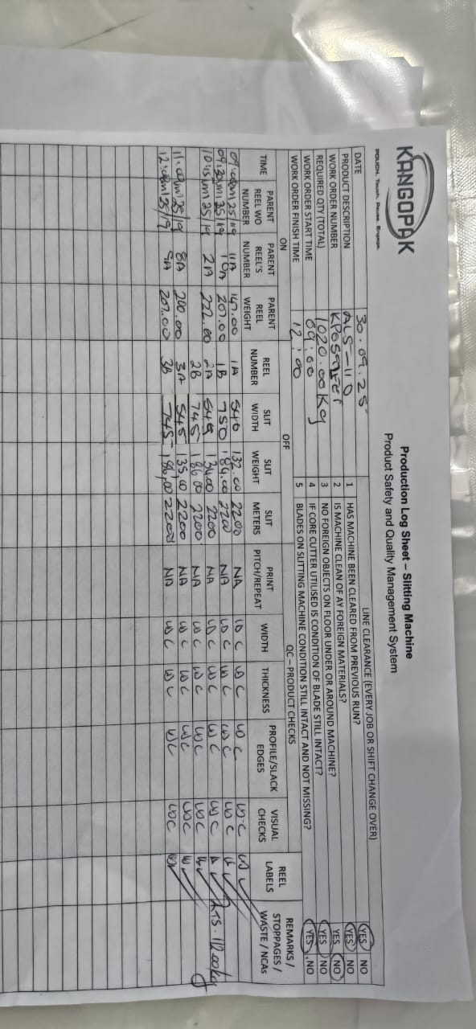
PHOTO 23: PRODUCTION LOG SHEET & JOB CARD - SLITTING
Location: Slitting department
Process Step: Job card generation and job card issuance.
Time: 14:00
Observations:
Document: Production log for slitting operations
Machine: Slitting Machine FES
Work Order: 592FES
Verified: Production Recording System – Traceability, Short Interval Controls, Quality Checks, Machine Checks Raw Material Input Specifications

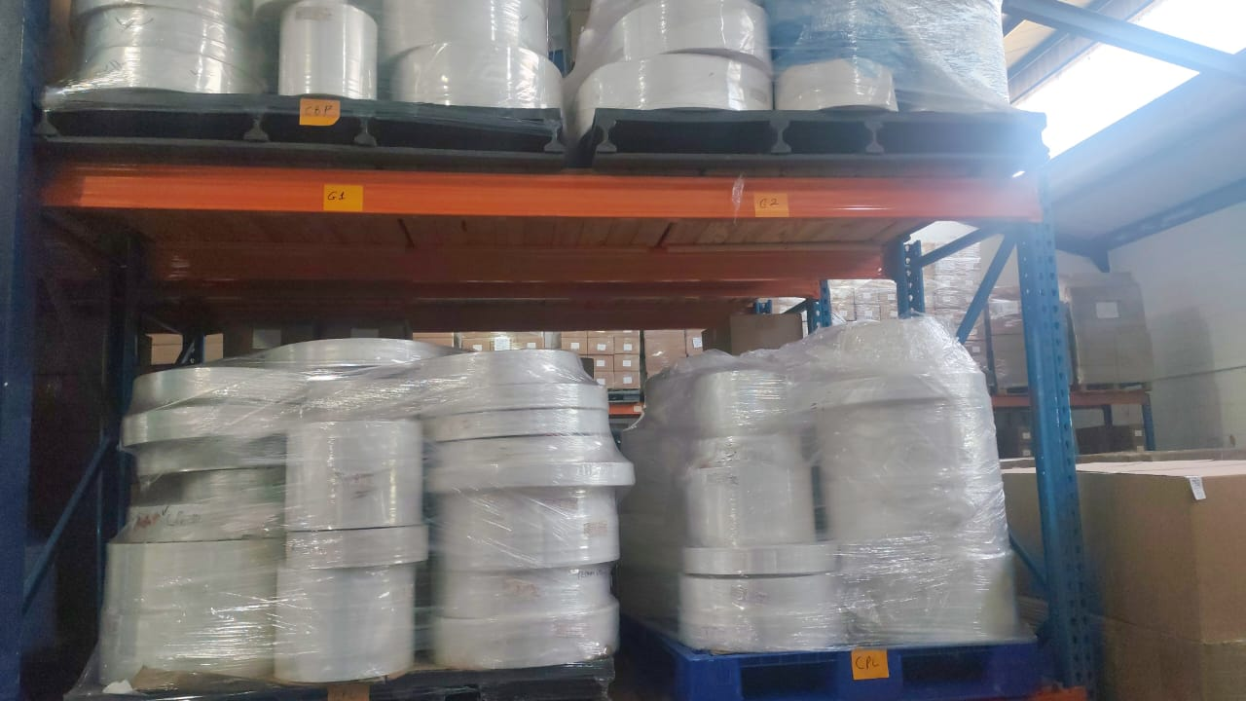
PHOTO 24: RAW MATERIALS STORAGE - RACK 1
Location: Warehouse
Process Step: Raw Materials storage
Time: 14:15
Observations:
Storage: Multi-tier racking system
Materials: Wrapped/protected
Organization: Systematic storage arrangement
Capacity: Adequate storage space
Verified: Storage of raw materials.

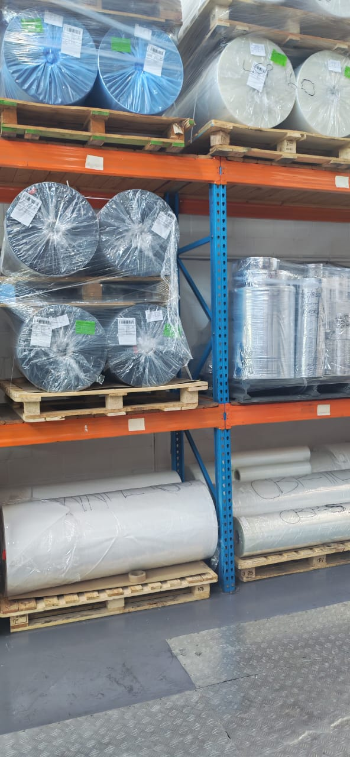
PHOTO 25: FINISHED GOODS STORAGE - RACK 2
Location: Warehouse
Process Step: Raw Materials storage
Time: 14:15
Observations:
Storage: Multi-tier racking system
Materials: Wrapped/protected
Organization: Systematic storage arrangement
Capacity: Adequate storage space
Verified: Storage of raw materials, Product segregation and storage

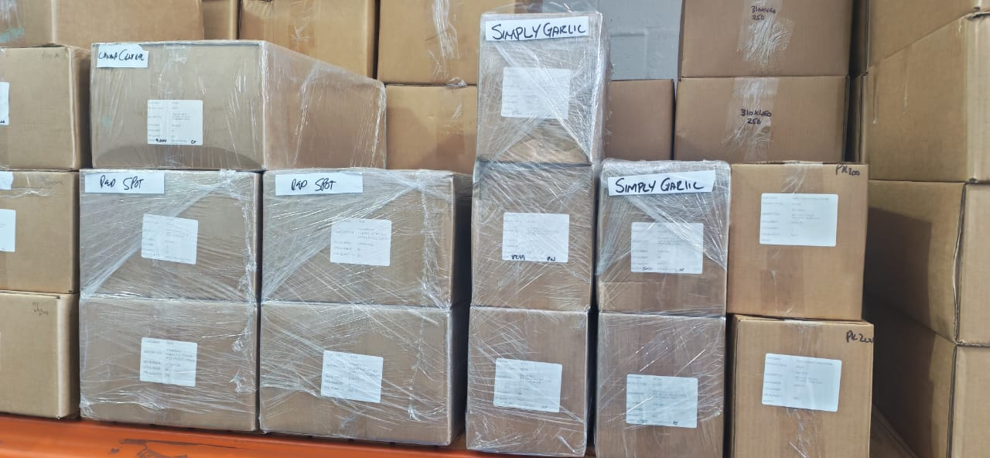

PHOTO 26: Finish Goods Storage
Location: Dispatch area - warehouse
Process Step: Customer orders ready for dispatch. Good sense to customer.
Time: 14:20
Observations:
Customer: Simply Green/Sentry Green labelled boxes
Organization: Boxes labelled and organized
Status: Ready for dispatch
Documentation: Customer information visible
Verified: Dispatch preparation area

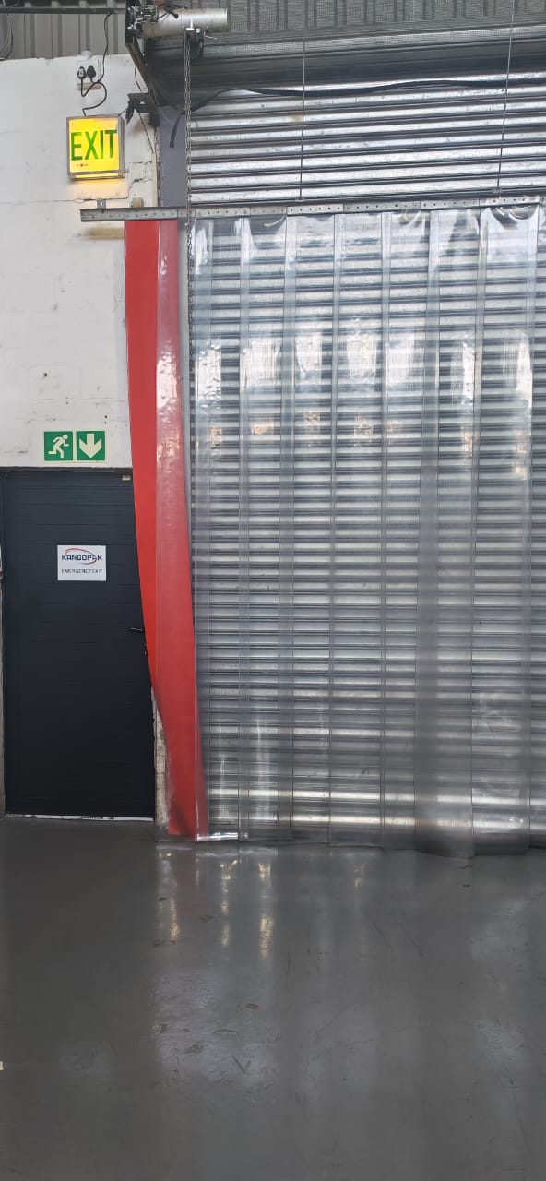
PHOTO 27: DISPATCH/RECIEPTS DOOR
Location: Dispatch/Receiving bay
Process Step: Final dispatch and raw material receipt / entry & exit point
Time: 14:25
Observations:
Exit Point: Roll-up dispatch door
Signage: EXIT clearly marked
Emergency Route: Green emergency exit signs visible
Access Control: Controlled dispatch and receiving area
BRCGS Relevance: incoming goods & Final point in process flow - dispatch
Verified: Dispatch/exit point - END OF PROCESS FLOW

VERIFICATION SUMMARY
Process Flow Verification Completed:
1. Raw Material Receipt
2. Material Storage
3. Production Planning
4. Material Preparation
5. Converting/Pouching
6. Sealing Operations
7. Quality Control
8. Finished Goods Storage
9. Dispatch

Critical Observations:
1. Active Production: Multiple work orders in progress during walk-through
2. Complete Flow: All process steps from receipt to dispatch verified

HARA Team Verification Statement:
The HARA team conducted a physical walk-through of the entire process flow on 30/09/2025
All process steps were observed in actual operation, from raw material receipt through to dispatch. The process flow diagram accurately reflects the actual operations observed. Evidence has been collected including photographs, work order numbers, and operator identification.

SIGN-OFF
HARA Team Members Present:

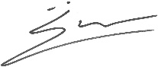
Name Position Signature Date

Michael Schlachter HARA Risk Team Leader __________ 30/09/2025

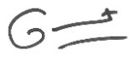
Gabrielle Gant HARA Risk Team Member 30/09/2025


Lyndsay Schlachter HARA Risk Team Member __________ 30/09/2025


Clive Schlachter HARA Risk Team Member __________ 30/09/2025

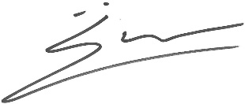
Verification Approved By:

Operations Manager: _________________ Name: Michael Schlachter Date: 30/09/2025

CONCLUSION:

Raw Material Flow: The raw material is stored in the warehouse, labelled, and covered with outer packaging. Slip sheets are used to prevent foreign bodies from contaminating the product. When practical, plastic pallets are utilised as much as possible. Raw Material that is “returned to stores” is covered with a blue liner, labelled with relevant traceability details, and stored back with other raw materials in the warehouse.

Drainage / Water Flow: There are no drains in the factory, only from ablutions to the outside. Any water that may spill onto the factory floor is cleaned up immediately as per the “Clean as you Go” Policy.

Water chiller units and water flow are closed systems. Maintenance is planned to prevent potential product safety risks from leaks at pipes, fittings, or connections.

Air Flow: The factory has no positive airflow, as all doors and windows are kept closed. However, “Whirly Birds” are situated on top of the roof for ventilation.

Finished Product Flow: When finished goods are packed from the production line into cartons, they are packed onto plastic pallets with slip sheets. Blue liners are utilised in the finished goods cartons to prevent contamination from chemicals, gas fumes from transport, pests, and/or dust. All finished goods are packed onto the finished goods shelving or palletised in the warehouse, ready for dispatch or storage.

WIP Flow: All WIP is palletised, covered where applicable, and stored in the warehouse. It is issued to production as and when needed. This WIP is identified with blue labels for easy segregation to prevent cross-contamination with finished goods.

People flow: People must stay in demarcated areas identified by yellow markings on the factory floor. Unauthorised access is restricted.
Employees entering the factory for the start and end of their shifts must sanitise, keep on the walkway, and go straight up to change rooms to change into their PPE. Contractors and visitors are handled by a responsible person, who issues PPE after reporting to reception.

Waste Flow: Set-up production waste is cleared from machines before start-up, weighed, recorded on Production Log Sheets, and segregated for destruction and disposal.

Trademark waste is weighed and documented on the Trademarked Waste Destruction & Disposal Record. The weight is recorded once the waste is destroyed, and the destroyed waste is disposed of. This disposal is then logged in the Trademarked Waste Destruction & Disposal Record. The baling process is adhered to.

Punch-outs (including Back Gusset Punches, Euro Slots, Tear Nicks, and Cropped Round Corners) are stored in designated blue bins on the factory floor to minimise the number of trips to the skip and reduce the risk of environmental pollution.

CRITICAL CONTROL POINT DECISION TREE

Step # | Process Activity - FLOW DIAGRAM | Process Variable | Product Attribute | Any Outsourced / subcontracted work | Raw Material Input | Rework Input | Waste Output
1 | Supplier Approval | Price  Quality  Quantity | Product Specification (Prod. Spec.) | Supply of Material | N/A | N/A | N/A
2 | Artwork Approval | Quality  Delivery Date | Prod. Spec. | Printing of Material | N/A | N/A | N/A
3 | Specification approval | Product Specification (Prod. Spec.)  Price | Prod. Spec. | None | N/A | N/A | N/A
4 | Order placement | Quantity  Delivery date  Price | Prod. Spec. | None | N/A | N/A | N/A
5 | Material receipt | Certificate of Conformance (CoC)  Delivery note Incoming Inspection | Raw Materials Specification (RM Spec.) | None | Raw Material / Consumables | N/A | N/A
6 | Raw Material Storage | Gauge demarcation | RM Spec:  Good condition  Width  Weight | None | Raw Material / Consumables | N/A | Pallet wrapping
7 | Planning / Allocation of Raw Material (RM) | Width  Weight  Raw Materials (RM) Availability  Description | Prod. Spec. | None | N/A | N/A | N/A
8 | Job card generation (Slitting Machine) | Prod. Spec.  Job Card number | Prod. Spec. | None | N/A | N/A | N/A
9 | Material Issue as per Job card (Slitting Machine) | Job Card – Description | RM Spec:  Width  Weight  Type | None | Relevant Raw Material | N/A | Poly wrap
10 | Cutting of Core – Core Cutter | Job card – Width Specification as per Job Card | 76’’ Core | None | Repurposed  Cores from Pouch Makers | N/A | Core Off Cuts
11 | Manual Stacker arrives at Line (Slitting Machine) | Job card – Material Specification  Works Order (WO) Number | Single sheeting film.  Clear, silver or printed.  Weight  Construction  Width  Gauge | None | Relevant Raw Material | N/A | Cores from previous Job
12 | Removal of outer packaging & load and Splice material.  (Slitting Machine) | Exposed raw material  Position on air shaft  Unwind direction  Inflation of air shaft. | RM Spec. | None | Relevant Raw Material | N/A | Cores from previous Job
13 | Set empty cores on rewind unit (Slitting Machine) | Job Card – Width Specification  Positioned on Air Shaft at rewind unit. | Empty 76’’ Core | None | Core | N/A | N/A
14 | Set blades (Slitting Machine) | Sharpness of blade  Correct blade positioning | Film slit as per Specifications | None | None | N/A | N/A
15 | Unloaded and Weighed (Slitting Machine) | Meters of Reel  Weight  Traceability Details | Finished Reels slit as per Specifications on Job Card | None | Unused Labels  Cello tape  Trim | N/A | Unwind Unit empty Core
16 | Checked for defects (Slitting Machine) | Quality | Short Interval Control | None | None | N/A | N/A
17 | Storage and Processing of waste:  Waste (Machine Waste, set-up, running, trim, cores) removed and stored for removal (Slitting Machine).  Baling Process | Weight of Waste | Waste packed into tubing | None | Plastic Tubing | N/A | Waste
18 | Return Raw Material to Stores (Slitting Machine) | Label  Weight | Supplier WO  Reel Number  Previous WO  Weight  Description  Returned By | None | Label  Pallet Wrapped | N/A | N/A
19 | Finished Slit Product strapped with clear tape and then covered with Blue liner and packed in Raw Materials/WIP Stores (Slitting Machine) | Weight  Meters  Material Description  Reel Number  Work Order Number (WO)  Actual Width  Number of joins  Operators Name  Gauge  Clear Tape  Liner | Label on reels  Reels palletised and pallet wrapped. | None | None | N/A | N/A
20 | Job card generation (Pouch Makers -DMF, AMJ, LYS & CMH) | Prod. Spec.  Job Card number | Prod. Spec. | None | N/A | N/A | N/A
21 | Material Issue as per Job card from warehouse raw material stores (Pouch Makers -DMF, AMJ, LYS & CMH) | Job Card – Description | RM Spec:  Width  Weight | None | Relevant Raw Material | N/A | Poly wrap
22 | Manual Stacker arrives at Line (Pouch Makers -DMF, AMJ, LYS & CMH) | Job card – Material Specification  Works Order (WO) Number | Single sheeting film.  Clear, silver or printed.  Weight  Construction  Width  Gauge | None | Relevant Raw Material | N/A | Cores from previous Job
23 | Removal of outer packaging & load, and Splice body and gusset material.  (Pouch Makers -DMF, AMJ, LYS & CMH) | Exposed raw material  Position on the air shaft  Unwind direction  Inflation of the air shaft. | RM Spec. | None | Relevant Raw Material | N/A | Cores from previous Job
24 | Set blade on vertical bar (Pouch Makers -DMF, AMJ, LYS & CMH) | Positioning of the bar  Sharpness of the blade  Correct blade positioning | Film slit in Half | None | None | N/A | N/A
25 | Check gusset punch tooling (Pouch Makers -DMF, AMJ, LYS & CMH) | Size of the punch hole diameter | As per Job card | None | None | N/A | N/A
26 | Key in pouch width  (Pouch Makers -DMF, AMJ, LYS & CMH) | Width of pouch  Punch positioning. | As per Job card | None | None | N/A | N/A
27 | Gusset insertion & Punch Out (Pouch Makers -DMF, AMJ, LYS & CMH) | Gusset material unwinding Direction | Gusset material film folded in half. | None | None | N/A | N/A
28 | Zipper insertion, hot seal and cooler bar (Pouch Makers -DMF, AMJ, LYS & CMH) | Zipper Direction (Customer/product side).  Size of Zipper.  Temperature of heat seal & chill bar.  Dwell  Pressure (TDP).  Teflon. | Zipper sealed to body film. | None | Relevant Zipper | N/A | N/A
29 | Cross seal – Gusset & Straight Seals & Cooler Bars (Pouch Makers -DMF, AMJ, LYS & CMH) | Position of heat seal bar and cooler bar.  TDP.  Teflon | Gusset sealed to body film or  Centre seal is sealed to body film. | None | None | N/A | N/A
30 | Trim (Pouch Makers -DMF, AMJ, LYS & CMH) | Winding unit switch.  Blade positioning.  Size of gusset | Smooth Edges.  Correct gusset height. | None | None | N/A | Trimmings
31 | Zipper Crusher Seal (Pouch Makers -DMF, AMJ, LYS & CMH) | TDP.  Position & appearance. | Zipper crushes on side seal. | None | None | N/A | N/A
32 | 3-point Seal (Pouch Makers -DMF, AMJ, LYS & CMH) | Positioning of the sealer.  Films are meeting correctly.  TDP | 3-point seal crush on gusset and body film. | None | None | N/A | N/A
33 | Side seal & Cooler Bars (Pouch Makers -DMF, AMJ, LYS & CMH) | TDP.  Positioning of the sealer. Appearance.  Teflon durability.  Punch hole position | Side seal is sealed on body and gusset and zipper crush, 3-point seal and centre of punch hole | None | None | N/A | N/A
34 | Features (tear nick; Euro slot, rounded corners) (Pouch Makers -DMF, AMJ, LYS & CMH) | Position  Sharpness of the blade | Cosmetics as per Job card | None | None | N/A | Off-cuts
35 | Straight middle cut at end (Pouch Makers -DMF, AMJ, LYS & CMH) | Sharpness of blade.  Position of the blade. | Two pouches are slit into individual pouches. | None | None | N/A | N/A
36 | Final cut into a pouch. (Pouch Makers -DMF, AMJ, LYS & CMH) | Width of side seals.  Edge appearance.  Timeliness of the blade. | Product is formed. | None | None | N/A | Off-cuts
37 | Checked for defects (Pouch Makers -DMF, AMJ, LYS & CMH) | Quality | Short Interval Control | None | None | N/A | N/A
38 | Liners are placed into cartons to pack finished goods. Cartons sealed with clear tape for storage and distribution. (Pouch Makers) | Carton liners  Counting of pouches.  Number of Cartons.  Label generation. | Product in box as per packing instructions | None | Cartons; plastic liners | N/A | N/A
39 | Storage and Processing of waste:  Waste (Machine Waste, set-up, running and off-cut) removed and stored for removal (Pouch Maker).  Baling Process | Weight of Waste | Waste packed into tubing | None | Plastic Tubing | N/A | Waste
40 | Return Raw Material to Stores (Pouch Makers) | Label  Weight | Supplier WO  Reel Number  Previous WO  Weight  Description  Returned By | None | Virgin Poly Liner  Label | N/A | N/A
41 | Finished Cartons or WiP Packed into cartons are stored in the warehouse in the Finished Goods Store (Pouch Makers) | Quantity  Description  Carton Number  Work Order Number (WO) | Label on Carton.  Cartons taped together with buff tape. | None | None | N/A | N/A
42 | Job Card Generation (Spout Inserter Machines) | Prod. Spec.  Job Card No. | Product Specifications. | None | None | N/A | N/A
43 | Caps counted & packed into liners | Quality | Cap, liner and carton | None | Caps | N/A | Soiled caps
44 | Raw Material and WiP are issued to the Spout Inserter from the warehouse in the Finished Goods Store (Spout Inserter Machines) as per the Job card. | Job Card - Description | RM/ Work in Progress (WiP) Specification:  Description  Width  Dimensions | None | Relevant RM and WiP | N/A | Cartons, liners
45 | WiP Pouches loaded into Spout Machine (Spout Inserter Machines) | Positioning of magazine. | Work in Progress (WiP) Specification:  Description  Dimensions | None | None | N/A | N/A
46 | Spouts fitments loaded into vibration bowl (Spout Inserter Machines) | Spout size. | RM Specification:  Description  Dimensions | None | None | N/A | N/A
47 | Set PLC specifications (Spout Inserter Machines) | Vibration setting  Pre-heat setting | As per Job Card | None | None | N/A | N/A
48 | Pouch Pick (Spout Inserter Machines) | Position of vacuum sucker | Pouch Picked, no change in product. | None | None | N/A | N/A
49 | Angle Cut (Spout Inserter Machines) | Positioning of Blade  Position of spout fitment | Pouch cropped as per product specification. | None | None | N/A | Off-cuts
50 | Spout Pick (Spout Inserter Machines) | Positioning of picking arm. | Spout picked, no change in product. | None | None | None | None
51 | Pouch Open (Spout Inserter Machines) | Position of vacuum sucker | Pouch sucked open at cropped opening. | None | None | None | None
52 | First sealing, 1 & 2 (Spout Inserter Machines) | Temperature  Dwell  Pressure | Sealed spout to pouch | None | None | None | None
53 | Hot seal 1 & 2 (Spout Inserter Machines) | Temperature  Dwell  Pressure | Sealed spout to pouch | None | None | None | None
54 | Hot seal 3 & 4 (Spout Inserter Machines) | Temperature  Dwell  Pressure | Sealed spout to pouch | None | None | None | None
55 | Cold Seal 1 & 2 (Spout Inserter Machines) | Temperature  Dwell  Pressure | Sealed spout to pouch | None | None | None | None
56 | Checked for defects (Spout Inserter Machines) | Quality | Short Interval Control (Production log sheet) | None | None | None | Rejected pouches
57 | Liners are placed into cartons to pack finished goods. Cartons sealed with clear tape for storage and distribution. (Spout Inserter Machines) | Carton liners  Counting of pouches.  No. of Cartons.  Label generation. | Product in box as per packing instruction on job card. | None | Cartons; plastic liners, Self-adhesive tape | None | None
58 | Storage and Processing of waste:  Waste (Machine Waste, set-up, running and off-cut) removed and stored for removal (Sout Inserter).  Baling Process | Number of pouches | Tubing utilised. | None | Plastic Tubing (Consumable) | None | Waste
59 | Palletise / shrink wrap | Pallet configuration  Correct label | Aa per packing instruction. Completely wrapped  Delivery Labels. | None | Shrink wrap | N/A | Core
60 | Storage & Distribution | Quantity  Description  Job No.  Carton No.  Customer details | Completely wrapped | None | None | N/A | N/A
61 | Returns:  Customer Returns: Complaint Handling procedure/Control of Non-Conforming Product Procedure.  Supplier Returns: Control of Non-Conforming Product Procedure. | Quantity  Description  Job No.  Carton No.  Customer details  NCA | Label on Carton and Reels  HOLD Sticker | None | None | Yes | None

RISK ASSESSMENT MATRIX

 | (S) Severity | Low (L) | Minor (Mi) | Moderate (Mo) | Major (Ma) | Extreme (E)
(L) Likelihood | Almost Certain (AC) | High Risk (H) | H | Extreme Risk (E) | E | E
(L) Likelihood | Likely (L) | Medium Risk (M) | H | H | E | E
(L) Likelihood | Possible (P) | Low Risk (L) | M | H | E | E
(L) Likelihood | Unlikely (U) | L | L | M | H | E
(L) Likelihood | Rare (R) | L | L | M | H | H

Likelihood (L) X Severity (S) = Risk Rating/Control Required

Significant Risk:
Yes (Y): High / Extreme Risk Rating
No (N): Low / Medium Risk Rating

Hazard Source
P = Present | G = Grow
I = Introduced at this step | S = Survive

HAZARD ANALYSIS
Step # | Process Activity | Potential Product Safety Hazard or Quality defect | List Hazards for each Process Step | Hazard Source | Acceptable level of Hazard | Preventive measures for each hazard | Likelihood | Severity | Rating | Significant Risk | Q1 | Q2 | Q3 | Q4 | Q5 | CCP | Remarks / additional preventive measures
1 | Supplier Approval | Quality | Non-Conforming Raw Material. | P | As per specifications | Supplier Approval & Performance Monitoring Procedure in place. | U | Mi | L | N | - | - | - | - | - | - | Supplier Risk assessment  BRC/FDA Approved Supplier/s
1 | Supplier Approval | Chemical | None | - | - | - | - | - | - | - | - | - | - | - | - | - | No product received on site at this point in time
1 | Supplier Approval | Foreign Objects | None | - | - | - | - | - | - | - | - | - | - | - | - | - | No product received on site at this point in time
1 | Supplier Approval | Microbiological | None | - | - | - | - | - | - | - | - | - | - | - | - | - | No product received on site at this point in time
2 | Artwork Approval | Quality | Misleading Labels: Incorrect Allergens/Safety information. Fraudulent use of Artwork | P | As per specifications | Specifications Procedure in place.  Graphic Design & Artwork Control Procedure in place  Security Procedure in place | R | L | L | N | - | - | - | - | - | - | No Printing on site  Artwork approved by customer
2 | Artwork Approval | Chemical | None | - | - | - | - | - | - | - | - | - | - | - | - | - | -
2 | Artwork Approval | Foreign Objects | None | - | - | - | - | - | - | - | - | - | - | - | - | - | No product received on site at this point in time
2 | Artwork Approval | Microbiological | None | - | - | - | - | - | - | - | - | - | - | - | - | - | No product received on site at this point in time
3 | Specification approval | Quality | Non-Conforming Raw Material/Finished Goods. | P | - | Specifications Procedure in place. | U | Mi | L | N | - | - | - | - | - | - | BRC/FDA Approved Supplier/s  Raw Material Specifications Register  Declaration of Compliance from Supplier  Pouch Specification Forms  Artwork Approval
3 | Specification approval | Chemical | Non-food Grade Inks.  Potential for unintended migration of substances into food or other hygiene sensitive product. | P | - | Specifications Procedure in place  Chemical and biological control procedure in place | R | Mo | M | N | - | - | - | - | - | - | No product received on site at this point in time  Raw Material Specifications Register  BRC/FDA Approved Supplier/s  Declaration of Compliance from Supplier  Analysis of film & migration report from Supplier.  Limitations of use on both Pouch Spec. Form and CoC
3 | Specification approval | Foreign Objects | None | - | - | - | - | - | - | - | - | - | - | - | - | - | No product received on site at this point in time
3 | Specification approval | Microbiological | None | - | - | - | - | - | - | - | - | - | - | - | - | - | No product received on site at this point in time
4 | Order placement | Quality | None | - | - | - | - | - | - | - | - | - | - | - | - | - | Raw material specification available.  No product received on site at this point in time
4 | Order placement | Chemical | None | - | - | - | - | - | - | - | - | - | - | - | - | - | No product received on site at this point in time
4 | Order placement | Foreign Objects | None | - | - | - | - | - | - | - | - | - | - | - | - | - | No product received on site at this point in time
4 | Order placement | Microbiological | None | - | - | - | - | - | - | - | - | - | - | - | - | - | No product received on site at this point in time
5 | Material receipt | Quality | Damaged.  Telescoping etc. Incorrect Specifications  Trademark Infringements  Product damaged in transit or during offloading.  Misprint.  Fraudulent Raw Materials. | P | As per specifications | Supplier Approval Procedure in place.  Transport, Storage & Distribution Procedure in place  Specifications Procedure in place  Product Authenticity Procedure (Food Fraud) | P | Mi | M | N | - | - | - | - | - | - | Incoming Inspection in place.  Trained operators  CoC verification with delivery note & specifications.  Customer signs off artwork proof before plates are made for printing.  Customer signed Pouch Spec Form before placement of order for Raw Material.  Supplier BRC/FDA certificated.  Inspection later in the process.  Trained forklift operators  Copy of signed artwork provided to Operators for visual inspection
5 | Material receipt | Chemical | No Food Grade Chemicals transported with Raw Materials increasing risk of contamination | P | None | Supplier Approval Procedure in place.  Transport, Storage & Distribution Procedure in place | R | Ma | H | Y | Y | Y | N | N | - | - | Incoming material inspection.  Chemicals not transported on same transport as raw or packaging material.  Supplier BRC/FDA certificated.  Vehicle Inspection taken place at raw material supplier as seen on copy of supplier delivery note.
5 | Material receipt | Foreign Objects | Pests; wood chips from damaged pallets during transportation or offloading. Insects/Pests present in the material from production.  Glass/Brittle plastic from Forklift | p | None | Supplier Approval Procedure in place.  Transport, Storage & Distribution procedure in place.  Glass and brittle plastic procedure in place. | U | Mo | M | N | - | - | - | - | - | - | Incoming material inspection  Supplier BRC/FDA Approved.  Slip Sheets utilised for transportation of material  Product protection  Inspection with short interval control (PLS) later in process.  Vehicle Inspection taken place at raw material supplier as seen on copy of supplier delivery note.  Trained forklift operators
5 | Material receipt | Microbiological | None | - | - | - | - | - | - | - | - | - | - | - | - | - | Product protected at delivery  Product undergoes no physical change
6 | Raw Material Storage | Quality | Damaged Product.  Malicious Intervention. | I | None | Transport, Storage & Distribution procedure in place.  Security Procedure in place. | U | Mi | L | N | - | - | - | - | - | - | Good storage conditions maintained.  Raw materials are stored in segregated storage area.  Visual inspection of product prior use.  Product protected, slip sheets used.  Product undergoes no physical change  Trained forklift operators
6 | Raw Material Storage | Chemical | Contamination from non-food grade chemicals/Malicious Intervention | I | None | Transport, Storage & Distribution procedure in place.  Security Procedure in place | R | Mo | M | N | - | - | - | - | - | - | Chemicals stored in locked room away from product.  Food Grade Lubricants & Cleaning agents only used. Material Safety Data available.  Product protected.  Raw Materials stored in separate area: Raw Materials stores  Product undergoes no physical change
6 | Raw Material Storage | Foreign Objects | Damaged pallets cause wood chips, pests, paint chips floors, Glass/Brittle plastic from Forklift  Foreign objects from damage to building structure | I | None | Transport, Storage & Distribution procedure in place.  Pest Control Procedure in place.  Cleaning Procedure in place  Foreign Body Contamination Control Procedure  Site standard procedure | U | Mo | M | N | - | - | - | - | - | - | Internal Self Audit.  Cleaning programme in place.  Product protection, slip sheets used.  Product undergoes no physical change  All product stored off the floors on pallets or racking and away from walls.  Trained forklift operators  High Level Cleaning
6 | Raw Material Storage | Microbiological | Bacteria from product handling (Corona Virus) | I | None | Transport, Storage & Distribution procedure in place.  Personnel Hygiene Procedure in place.  Chemical & Biological Control Procedure in place | R | Mo | M | N | - | - | - | - | - | - | Product protection.  Hand Wash Facilities provided.  Trained Personnel.  Product undergoes no physical change  Based on this risk assessment the water used in the hand washing facilities is tested on an annual basis.  Annual validation of hand washing by swab tests
7 | Planning / Allocation of Raw Material | Quality | Shelf life of Raw Material | P | 1 year from receipt of material. | Transport, Storage & Distribution procedure in place. | R | Mi | L | N | - | - | - | - | - | - | FIFO practise.  Raw Materials Labelled  Product undergoes no physical change
7 | Planning / Allocation of Raw Material | Chemical | None | - | - | - | - | - | - | - | - | - | - | - | - | - | Product undergoes no physical change
7 | Planning / Allocation of Raw Material | Foreign Objects | None | - | - | - | - | - | - | - | - | - | - | - | - | - | Product undergoes no physical change
7 | Planning / Allocation of Raw Material | Microbiological | None | - | - | - | - | - | - | - | - | - | - | - | - | - | Product undergoes no physical change
8 | Job card generation (Slitting Machine) | Quality | Incorrect specifications on Job Card | I | None | Specifications procedure in place | U | Mo | M | N | - | - | - | - | - | - | Approval of Specifications by customer.  Trained personnel generating job card  Job Card.  Product undergoes no physical change
8 | Job card generation (Slitting Machine) | Chemical | None | - | - | - | - | - | - | - | - | - | - | - | - | - | Product undergoes no physical change
8 | Job card generation (Slitting Machine) | Foreign Objects | None | - | - | - | - | - | - | - | - | - | - | - | - | - | Product undergoes no physical change
8 | Job card generation (Slitting Machine) | Microbiological | None | - | - | - | - | - | - | - | - | - | - | - | - | - | Product undergoes no physical change
9 | Material Issue as per Job card (Slitting Machine) | Quality | Incorrect material issued. | I | None | In-Process Control in place: Documented Process Checking  Traceability procedure in place | P | Mi | M | N | - | - | - | - | - | - | Short Interval Control & Job Card initial.  Raw material identifiable.  Trained personnel.  Labels  Job Card  Product undergoes no physical change
9 | Material Issue as per Job card (Slitting Machine) | Chemical | None | - | - | - | - | - | - | - | - | - | - | - | - | - | No chemicals present in this process  Product undergoes no physical change
9 | Material Issue as per Job card (Slitting Machine) | Foreign Objects | Glass, wood splinters from supplier pallets, dust as outer packaging is removed, pests.  Foreign objects from damage to building structure | I | None | Glass and brittle plastic procedure in place.  Housekeeping & Cleaning procedure in place  Incident Reporting procedure in place  Pest control procedure in place  Site standard procedure | U | Mo | M | N | - | - | - | - | - | - | Product undergoes no physical change  Incoming Raw Material Inspection of material packaging and pallets.
9 | Material Issue as per Job card (Slitting Machine) | Microbiological | Bacteria from product handling | I | None | Personnel Hygiene Procedure & Standard in place  Housekeeping & Cleaning Procedure in place  Chemical & Biological Control Procedure in place | R | Mo | M | N | - | - | - | - | - | - | Washing / sanitising of Hands  Maintenance Cleaning of equipment.  Product undergoes no physical change  Trained personnel  Based on this risk assessment the water used in the hand washing facilities is tested on an annual basis.  Annual validation of hand washing by swab tests
10 | Cutting of Core – Core Cutter | Quality | None | - | - | - | - | - | - | - | - | - | - | - | - | - | Product undergoes no physical change
10 | Cutting of Core – Core Cutter | Chemical | None | - | - | - | - | - | - | - | - | - | - | - | - | - | Product undergoes no physical change
10 | Cutting of Core – Core Cutter | Foreign Objects | Core Dust  Broken Blade | I | None | Housekeeping & Cleaning Procedure in Place | R | Mo | M | N | - | - | - | - | - | - | Product undergoes no physical Change  Clean as you go Policy  Sharps Policy  Blade register for issue of blades
10 | Cutting of Core – Core Cutter | Microbiological | None | - | - | - | - | - | - | - | - | - | - | - | - | - | Product undergoes no physical change
11 | Manual Stacker arrives at Line (Slitting Machine) | Quality | Incorrect material specification loaded onto machine | I | None | In-Process Control in place: Documented Process Checking. | P | Mi | M | N | - | - | - | - | - | - | Raw material identified  Raw material batch number recorded on Process control sheets.  Segregation of materials per machine and label check to see matches materials specified on job card.  Trained Personnel. Initial Job Card & PLS, SIC Product undergoes no physical change
11 | Manual Stacker arrives at Line (Slitting Machine) | Chemical | None | - | - | - | - | - | - | - | - | - | - | - | - | - | No chemicals used at this part of the machine  Product undergoes no physical change
11 | Manual Stacker arrives at Line (Slitting Machine) | Foreign Objects | Glass / brittle plastic.  Jewellery, pests, paint chips floors  Foreign objects from damage to building structure | I | None | Glass and brittle plastic procedure in place.  Housekeeping & Cleaning procedure in place  Personal Hygiene Standard in place.  Pest control procedure in place.  Site standard procedure | R | Mo | M | N | - | - | - | - | - | - | Glass and brittle plastics register  Trained operator.  Line clearance in place.  Incident management  Product undergoes no physical change. Product is protected by suitable outer covering.  “Tread Plates” installed to protect the flooring and avoid damage
11 | Manual Stacker arrives at Line (Slitting Machine) | Microbiological | Bacteria from product handling | I | None | Personnel Hygiene Procedure & Standard in place  Housekeeping & Cleaning Procedure in place  Chemical & Biological Control Procedure in place | R | Mo | M | N | - | - | - | - | - | - | Washing / sanitising of Hands.  Hand Wash Basin.  Personnel trained on personal hygiene practices  Product undergoes no physical change  Trained personnel  Based on this risk assessment the water used in the hand washing facilities tested on an annual basis.  Annual validation of hand washing by swab tests
12 | Removal of outer packaging & load and Splice material.  (Slitting Machine) | Quality | Incorrect material specification loaded onto machine  Telescoping Reels form Supplier | I | None | In-Process Control in place: Documented Process Checking  Control of Non-Conforming Procedure. | P | Mi | M | N | - | - | - | - | - | - | Raw material identified  Product inspection  Raw material batch number recorded on Process control sheets.  Segregation of materials per machine and label check to see matches materials specified on job card.  Trained Personnel. Initial Job Card & PLS, SIC  Bright Lights above machines.
12 |  | Chemical | None | - | - | - | - | - | - | - | - | - | - | - | - | - | No chemicals used at this part of the machine Product undergoes no physical change
12 |  | Foreign Objects | Glass / brittle plastic  Jewellery, blades, pests  Temporary Modification | I | None | Glass and brittle plastic procedure in place.  Housekeeping & Cleaning procedure in place  Sharps Policy  Personal Hygiene Standard in place.  Pest control procedure in place  Foreign Body Contamination Procedure. | R | Mo | M | N | - | - | - | - | - | - | Trained operator.  Line clearance in place.  Incident management  Product undergoes no physical change  Designated Area for removal of outer packaging  Process Control checks (PLS)  Bright Lights above machines.
12 |  | Microbiological | Bacteria from product handling | I | None | Personnel Hygiene Procedure & Standard in place  Housekeeping & Cleaning Procedure in place  Chemical & Biological Control Procedure in place | R | Mo | M | N | - | - | - | - | - | - | Washing / sanitising of Hands after removal of outer packaging before product handling.  Hand Wash Basin.  Personnel trained on personal hygiene practices  Product undergoes no physical change  Designated Area for removal of outer packaging  Trained personnel  Annual validation of hand washing by swab tests  Based on this risk assessment the water used in the hand washing facilities is tested on an annual basis.
13 | Set empty cores on rewind unit (Slitting Machine) | Quality | None | - | - | - | - | - | - | - | - | - | - | - | - | - | Product undergoes no physical change
13 | Set empty cores on rewind unit (Slitting Machine) | Chemical | None | - | - | - | - | - | - | - | - | - | - | - | - | - | Product undergoes no physical change
13 | Set empty cores on rewind unit (Slitting Machine) | Foreign Objects | Glass / brittle plastic  Jewellery, blades, pests  Temporary Modification  Core Dust | I | None | Glass and brittle plastic procedure in place.  Housekeeping & Cleaning procedure in place  Sharps Policy  Personal Hygiene Standard in place.  Pest control procedure in place  Foreign Body Contamination Procedure. | R | Mo | M | N | - | - | - | - | - | - | Trained operator.  Line clearance in place.  Incident management  Product undergoes no physical change  Bright Lights above machines.
13 | Set empty cores on rewind unit (Slitting Machine) | Microbiological | None | - | - | - | - | - | - | - | - | - | - | - | - | - | Product undergoes no physical change
14 | Set blades (Slitting Machine) | Quality | Sharpness of blade | P | None | In-Process Control in place | P | L | L | N | - | - | - | - | - | - | Change Blade when blunt as seen on Blade register  Pre-start up blade inspection at each shift
14 | Set blades (Slitting Machine) | Chemical | None | - | - | - | - | - | - | - | - | - | - | - | - | - | Material safety datasheets available,  Post maintenance cleaning in place  Food grade (NSF) chemicals used during machine maintenance/cleaning
14 | Set blades (Slitting Machine) | Foreign Objects | Blade chips/Broken Fragments  Temporary Modification | I | None | In-Process Control in place: Documented Process Checking  Foreign Body Contamination Procedure | R | Mo | M | N | - | - | - | - | - | - | Blades are checked prior to start up at shift handover – refer to production log sheets  Blade register for issue of blades Process Control checks (PLS)
14 | Set blades (Slitting Machine) | Microbiological | Bacteria from product handling | I | None | Personnel Hygiene Procedure & Standard in place  Housekeeping & Cleaning Procedure in place  Chemical & Biological Control Procedure in place | U | Mo | M | N | - | - | - | - | - | - | Washing / sanitising of Hands.  Hand Wash Basin.  Personnel trained on personal hygiene practices  Annual validation of hand washing by swab tests
15 | Unloaded and Weighed (Slitting Machine) | Quality | Malicious intervention | I | None | Transport, storage and distribution procedure in place  Security procedure in place | R | Mo | M | N | - | - | - | - | - | - | Product labelling  Traceability procedure in place  Access control  Visitors’ registers
15 | Unloaded and Weighed (Slitting Machine) | Chemical | None | - | - | - | - | - | - | - | - | - | - | - | - | - | No chemicals used at this process step
15 | Unloaded and Weighed (Slitting Machine) | Foreign Objects | Pests, dirt, glass and brittle plastic, Jewellery | I | None | Personal Hygiene Standard in place  Glass and brittle plastic procedure in place.  Housekeeping & Cleaning Procedure in place  Pest control procedure in place | U | Mo | M | N | - | - | - | - | - | - | Glass and brittle plastics register.  Incident management.  Bright Lights above Machines.
15 | Unloaded and Weighed (Slitting Machine) | Microbiological | Bacteria from product handling | I | None | Personnel Hygiene Procedure & Standard in place  Chemical & Biological Control Procedure in place | R | Mo | M | N | - | - | - | - | - | - | Product is handled on outside  Carton Liners  Glass and brittle plastics register  Personnel trained on personal hygiene practices  Based on this risk assessment the water used in the hand washing facilities is tested on an annual basis.  Hand Wash Basin.  Annual validation of hand washing by swab tests
16 | Checked for defects (Slitting Machine) | Quality | Incorrect Specification | P | None | In-Process Control in place: Documented Process Checking | P | Mi | M | N | - | - | - | - | - | - | Job Card  1st off Sample.  Train Personnel  Documented product quality checks on PLS  Bright Lights above machines.
16 | Checked for defects (Slitting Machine) | Chemical | None | - | - | - | - | - | -- | - | - | - | - | - | - | - | No chemicals used at this process step
16 | Checked for defects (Slitting Machine) | Foreign Objects | Glass / brittle plastic, Jewellery, blades, pests  Temporary Modification | I | None | In-Process Control in place: Documented Process Checking Glass and brittle plastic procedure in place.  Sharps Policy  Personal Hygiene Standard in place  Pest control procedure in place  Foreign Body Contamination Procedure | U | Mo | M | N | - | - | - | - | - | -- | Glass and brittle plastics register.  Incident management.  Pre-start-up checklist  Documented visual product inspection  Pouch is sealed at this stage  Process Control checks (PLS)  Bright Lights above machines.
16 | Checked for defects (Slitting Machine) | Microbiological | Bacteria from product handling | I | None | Personnel Hygiene Procedure & Standard in place  Housekeeping & Cleaning Procedure in place  Chemical & Biological Control Procedure in place | U | Mo | M | N | - | - | - | - | - | - | Product is handled on outside.  Washing / sanitising of Hands  Hand Wash Basin.  Inspected sample used as retention.  Based on this risk assessment the water used in the hand washing facilities is tested on an annual basis.  Annual validation of hand washing by swab tests
17 | Storage and Processing of waste:  Waste (Machine Waste, set-up, running, trim, cores) removed and stored for removal (Slitting Machine).  Baling Process | Quality | Fraudulent use of trademark waste | I | None | Waste Management Procedure in place | U | Mo | M | N | - | - | - | - | - | - | Trademark waste is rendered unusable through an in-house destruction process.
17 |  | Chemical | None | - | - | - | - | - | - | - | - | - | - | - | - | - | No chemicals used at this process step
17 |  | Foreign Objects | Punch Outs Pieces of Trim. | P | None | In-Process Control in place: Documented Process Checking  Waste management procedure in place | P | Mi | M | N | - | - | - | - | - | - | Line Clearance as per PLS  Trained Personnel Initials Line Clearance on PLS
17 |  | Microbiological | None | - | - | - | - | - | -- | - | - | - | - | - | - | - | No product handling at this step
18 | Return Raw Material to Stores (Slitting Machine) | Quality | Untraceable product, incorrect labelling Malicious intervention | I | None | Traceability procedure in place  Transport, storage and distribution procedure in place  Security procedure in place | U | Mo | M | N | - | - | - | - | - | - | Return to store labels  Access control  Visitors’ registers  Product is protected covered with blue liner, slip sheets on pallets
18 | Return Raw Material to Stores (Slitting Machine) | Chemical | None | - | - | - | - | - | - | - | - | - | - | - | - | - | Material safety datasheets available,  Post maintenance cleaning in place  Food grade (NSF) chemicals used during machine maintenance.  No Chemicals used at this step.
18 | Return Raw Material to Stores (Slitting Machine) | Foreign Objects | Damaged pallets cause wood chips, pests. Jewellery, | P | None | Transport, storage and distribution procedure in place  Housekeeping & Cleaning Procedure in place  Pest Control procedure in place  Personal Hygiene Standard in place | U | Mo | M | N | - | - | - | - | - | - | Product protection  Product undergoes no physical change
18 | Return Raw Material to Stores (Slitting Machine) | Microbiological | Bacteria from product handling | I | None | Personnel Hygiene Procedure & Standard in place  Housekeeping & Cleaning Procedure in place  Chemical & Biological Control Procedure in place | U | Mo | M | N | - | - | - | - | - | - | Material handled so that the surface that comes into contact with hands and equipment does not come into contact with food.  Hands are sanitised.  Based on this risk assessment the water used in the hand washing facilities is tested on an annual basis.  Annual validation of hand washing by swab tests
19 | Finished Slit Product strapped with clear tape and then covered with blue liner and packed in Raw Materials/WIP Stores (Slitting Machine) | Quality | Malicious intervention | I | None | Transport, storage and distribution procedures in place  Security procedure in place | R | Mo | M | N | - | - | - | - | - | - | Product labelling  Traceability procedure in place  Access control  Visitors’ registers
19 |  | Chemical | None | - | - | - | - | - | - | - | - | - | - | - | - | - | Material safety datasheets available,  Post maintenance cleaning in place  Food grade (NSF) chemicals used during machine maintenance.  No Chemicals used at this step.
19 |  | Foreign Objects | None | - | - | - | - | - | - | - | - | - | - | - | - | - | Product is stored in designated area.  Cleaning in place,  Pest control in place  Good Storage practices
19 |  | Microbiological | None | - | - | - | - | - | - | - | - | - | - | - | - | - | Product Protection
20 | Job card generation  (Pouch Makers) | Quality | Incorrect specifications on Job Card | I | None | Specifications procedure in place | U | Mo | M | N | - | - | - | - | - | - | Approval of Specifications by customer.  Trained personnel generating job card  Job Card.  Product undergoes no physical change
20 | Job card generation  (Pouch Makers) | Chemical | None | - | - | - | - | - | - | - | - | - | - | - | - | - | Product undergoes no physical change
20 | Job card generation  (Pouch Makers) | Foreign Objects | None | - | - | - | - | - | - | - | - | - | - | - | - | - | Product undergoes no physical change
20 | Job card generation  (Pouch Makers) | Microbiological | None | - | - | - | - | - | - | - | - | - | - | - | - | - | Product undergoes no physical change
21 | Material Issue as per Job Card  (Pouch Makers) | Quality | Incorrect material specification issued. | I | None | In-Process Control in place: Documented Process Checking  Traceability procedure in place | P | Mi | M | N | - | - | - | - | - | - | Short Interval Control & Job Card initial.  Raw material identifiable.  Trained personnel.  Labels  Job Card  Product undergoes no physical change
21 | Material Issue as per Job Card  (Pouch Makers) | Chemical | None | - | - | - | - | - | - | - | - | - | - | - | - | - | No chemicals present in this process  Product undergoes no physical change
21 | Material Issue as per Job Card  (Pouch Makers) | Foreign Objects | Glass, wood splinters from supplier pallets, dust as outer packaging is removed, pests.  Foreign objects from damage to building structure | I | None | Glass and brittle plastic procedure in place.  Housekeeping & Cleaning procedure in place  Incident Reporting procedure in place  Pest control procedure in place  Site standard procedure | U | Mo | M | N | - | - | - | - | - | - | Product undergoes no physical change  Incoming Raw Material Inspection of material packaging and pallets.
21 | Material Issue as per Job Card  (Pouch Makers) | Microbiological | Bacteria from product handling | I | None | Personnel Hygiene Procedure & Standard in place  Housekeeping & Cleaning Procedure in place  Chemical & Biological Control Procedure in place | R | Mo | M | N | - | - | - | - | - | - | Washing / sanitising of Hands  Maintenance Cleaning of equipment.  Product undergoes no physical change  Trained personnel  Based on this risk assessment the water used in the hand washing facilities is tested on an annual basis.  Annual validation of hand washing by swab tests
22 | Manual Stacker arrives at Line (Pouch Makers) | Quality | Incorrect material specification loaded onto machine | I | None | In-Process Control in place: Documented Process Checking. | P | Mi | M | N | - | - | - | - | - | - | Raw material identified  Raw material batch number recorded on Process control sheets.  Segregation of materials per machine and label check to see matches materials specified on job card.  Trained Personnel. Initial Job Card & PLS, SIC Product undergoes no physical change
22 | Manual Stacker arrives at Line (Pouch Makers) | Chemical | None | - | - | - | - | - | - | - | - | - | - | - | - | - | No chemicals used at this part of the machine  Product undergoes no physical change
22 | Manual Stacker arrives at Line (Pouch Makers) | Foreign Objects | Glass / brittle plastic.  Jewellery, pests, paint chips floors  Foreign objects from damage to building structure | I | None | Glass and brittle plastic procedure in place.  Housekeeping & Cleaning procedure in place  Personal Hygiene Standard in place.  Pest control procedure in place.  Site standard procedure | R | Mo | M | N | - | - | - | - | - | - | Glass and brittle plastics register  Trained operator.  Line clearance in place.  Incident management  Product undergoes no physical change. Product is protected by suitable outer covering.  “Tread Plates” installed to protect the flooring and avoid damage
22 | Manual Stacker arrives at Line (Pouch Makers) | Microbiological | Bacteria from product handling | I | None | Personnel Hygiene Procedure & Standard in place  Housekeeping & Cleaning Procedure in place  Chemical & Biological Control Procedure in place | R | Mo | M | N | - | - | - | - | - | - | Washing / sanitising of Hands.  Hand Wash Basin.  Personnel trained on personal hygiene practices  Product undergoes no physical change  Trained personnel  Based on this risk assessment the water used in the hand washing facilities is tested on an annual basis.  Annual validation of hand washing by swab tests
23 | Removal of outer packaging & load and Splice body and gusset material.  (Pouch Makers) | Quality | Incorrect material specification loaded onto machine.  Telescoping Reels | I | None | In-Process Control in place: Documented Process Checking  Control of Non-Conforming Product Procedure | P | Mi | M | N | - | - | - | - | - | - | Raw material identified  Product inspection  Raw material batch number recorded on Process control sheets.  Segregation of materials per machine and label check to see matches materials specified on job card.  Trained Personnel. Initial Job Card & PLS, SIC  Bright Lights above machines.
23 |  | Chemical | None | - | - | - | - | - | - | - | - | - | - | - | - | - | No chemicals used at this part of the machine Product undergoes no physical change
23 |  | Foreign Objects | Glass / brittle plastic  Jewellery, blades, pests  Temporary Modification | I | None | Glass and brittle plastic procedure in place.  Housekeeping & Cleaning procedure in place  Sharps Policy  Personal Hygiene Standard in place.  Pest control procedure in place  Foreign Body Contamination Procedure. | R | Mo | M | N | - | - | - | - | - | - | Trained operator.  Line clearance in place.  Incident management  Product undergoes no physical change  Designated Area for removal of outer packaging  Process Control checks (PLS)  Bright Lights above machines.
23 |  | Microbiological | Bacteria from product handling | I | None | Personnel Hygiene Procedure & Standard in place  Housekeeping & Cleaning Procedure in place  Chemical & Biological Control Procedure in place | R | Mo | M | N | - | - | - | - | - | - | Washing / sanitising of Hands after removal of outer packaging before product handling.  Hand Wash Basin.  Personnel trained on personal hygiene practices  Product undergoes no physical change  Designated Area for removal of outer packaging  Trained personnel  Annual validation of hand washing by swab tests  Based on this risk assessment the water used in the hand washing facilities is tested on an annual basis.
24 | Set blade on vertical bar (Pouch Makers) | Quality | Sharpness of blade | P | None | In-Process Control in place | P | L | L | N | - | - | - | - | - | - | Change Blade when blunt as seen on Blade register  Pre-start up blade inspection at each shift
24 | Set blade on vertical bar (Pouch Makers) | Chemical | None | - | - | - | - | - | - | - | - | - | - | - | - | - | Material safety datasheets available,  Post maintenance cleaning in place  Food grade (NSF) chemicals used during machine maintenance/cleaning
24 | Set blade on vertical bar (Pouch Makers) | Foreign Objects | Blade chips  Temporary Modification | I | None | In-Process Control in place: Documented Process Checking  Foreign Body Contamination Procedure | R | Mo | M | N | - | - | - | - | - | - | Blades are checked prior to start up at shift handover – refer to production log sheets  Blade register for issue of blades Process Control checks (PLS)
24 | Set blade on vertical bar (Pouch Makers) | Microbiological | Bacteria from product handling | I | None | Personnel Hygiene Procedure & Standard in place  Housekeeping & Cleaning Procedure in place  Chemical & Biological Control Procedure in place | U | Mo | M | N | - | - | - | - | - | - | Washing / sanitising of Hands.  Hand Wash Basin.  Personnel trained on personal hygiene practices  Annual validation of hand washing by swab tests
25 | Check gusset punch tooling (Pouch Makers) | Quality | Sharpness of Punch. | P | None | In-Process Control in place: Documented Process Checking | P | L | L | N | - | - | - | - | - | - | Documented visual product inspection  Documented machine check of equipment
25 | Check gusset punch tooling (Pouch Makers) | Chemical | None | - | - | - | - | - | - | - | - | - | - | - | - | - | Material safety datasheets available,  Post maintenance cleaning in place  Food grade (NSF) chemicals used during machine maintenance
25 | Check gusset punch tooling (Pouch Makers) | Foreign Objects | Glass / brittle plastic, Gusset Punch out, Jewellery  Temporary Modification | I | None | Glass and brittle plastic procedure in place.  Housekeeping & Cleaning procedure in place  Personal Hygiene Standard in place.  In-Process Control in place: Documented Process Checking  Foreign Body Contamination Procedure | U | Mo | M | N | - | - | - | - | - | - | Trained operator.  Line clearance in place.  Incident management  Documented visual product inspection  Documented machine check of equipment  Process Control checks (PLS)
25 | Check gusset punch tooling (Pouch Makers) | Microbiological | None | I | None | - | - | - | - | - | - | - | - | - | - |  | No product handling at this step  Product undergoes no physical change
26 | Key in pouch width  (Pouch Makers) | Quality | Incorrect Pouch Width | I | None | In-Process Control in place: Documented Process Checking | R | Mo | M | N |  | - | - | - | - | - | Train Personnel,  Job Card  Product undergoes no physical change  Documented product specification checks  1st off Sample
26 | Key in pouch width  (Pouch Makers) | Chemical | None | - | - | - | - | - | - | - | - | - | - | - | - | - | Product undergoes no physical change
26 | Key in pouch width  (Pouch Makers) | Foreign Objects | None | - | - | - | - | - | - | - | - | - | - | - | - | - | Product undergoes no physical change
26 | Key in pouch width  (Pouch Makers) | Microbiological | None | - | - | - | - | - | - | - | - | - | - | - | - | - | Product undergoes no physical change  No product handling at this step
27 | Gusset insertion & Punch Out (Pouch Makers) | Quality | Incorrect Gusset Tooling | I | None | In-Process Control in place: Documented Process Checking | U | Mo | M | N | - | - | - | - | - | - | 1st off Sample  Documented product specification checks on PLS  Job Card  Trained personnel
27 | Gusset insertion & Punch Out (Pouch Makers) | Chemical | None | - | - | - | - | - | - | - | - | - | - | - | - | - | Material safety datasheets available,  Post maintenance cleaning in place  Food grade (NSF) chemicals used during machine maintenance
27 | Gusset insertion & Punch Out (Pouch Makers) | Foreign Objects | Punch Outs  Temporary Modification | I | None | In-Process Control in place: Documented Process Checking  Foreign Body Contamination Procedure | U | Mo | M | N | - | - | - | - | - | - | Line clearance in place.  Cleaning Trained operators.  Documented visual product inspection  Documented machine check of equipment  Process Control checks (PLS)
27 | Gusset insertion & Punch Out (Pouch Makers) | Microbiological | None | - | - | - | - | - | - | - | - | - | - | - | - | - | No product handling at this step
28 | Zipper insertion, hot seal and cooler bar (Pouch Makers) | Quality | Weak Seal Strength  Incorrect Zipper Utilisation.  Incorrect direction of Zipper Inserted  Brittle seal from high heat causing zipper to tear | I | None | In-Process Control in place: Documented Process Checking | P | Mi | M | N | - | - | - | - | - | - | 1st off Sample  Labels  Documented product specification quality checks on PLS  Job Card  Trained personnel  Process specifications on Job Card
28 | Zipper insertion, hot seal and cooler bar (Pouch Makers) | Chemical | If applicable -Possible leaking of “descale” solution from cooler bars. | I | None | Food Grade “descale” used if applicable.  Maintenance: Condition monitoring | R | L | L | N | - | - | - | - | - | - | Material safety datasheets available.  Post maintenance cleaning in place.  Food grade (NSF) chemicals used during machine maintenance.
28 | Zipper insertion, hot seal and cooler bar (Pouch Makers) | Foreign Objects | Glass / brittle plastic, Splicing Tape, Teflon strands.  Temporary Modification | I | None | Maintenance Procedure in place  Glass and brittle plastic procedure in place.  In-Process Control in place: Documented Process Checking  Foreign Body Contamination Procedure | U | Mo | M | N | - | - | - | - | - | - | Glass and brittle plastics register  Teflon inspected as per maintenance plan  Incident management  Documented visual product inspection  Process Control checks (PLS)
28 | Zipper insertion, hot seal and cooler bar (Pouch Makers) | Microbiological | Bacteria from product handling  Bacteria from water leaking at connections of pipes to cooler bars from chiller unit. | I | None | Personnel Hygiene Procedure & Standard in place  Housekeeping & Cleaning Procedure in place  Chemical & Biological Control Procedure in place  Water is constantly circulating in the unit. Maintenance: Condition monitoring | R | Mo | M | N | - | - | - | - | - | - | Washing / sanitising of Hands.  Hand Wash Basin.  Personnel trained on personal hygiene practices  Based on this risk assessment the water used in the hand washing facilities is tested on an annual basis.  Annual validation of hand washing by swab tests  Environmental Monitoring Plan.
29 | Cross seal – Gusset & Straight Seals & Cooler Bars (Pouch Makers) | Quality | Weak Seal Strength | I | None | In-Process Control in place: Documented Process Checking | U | Mo | M | N | - | - | - | - | - | - | 1st off Sample  Job Card  Documented product specification quality checks on PLS  Trained personnel  Pre-Start Up Checklist as per PLS
29 |  | Chemical | If applicable -Possible leaking of “descale” solution from cooler bars. | I | None | Food Grade “descale” used if applicable.  Maintenance: Condition monitoring | R | L | L | N | - | - | - | - | - | - | Material safety datasheets available.  Post maintenance cleaning in place.  Food grade (NSF) chemicals used during machine maintenance.
29 |  | Foreign Objects | Glass / brittle plastic  Jewellery  Temporary Modification | I | None | Maintenance Procedure in place  Glass and brittle plastic procedure in place.  In-Process Control in place: Documented Process Checking  Personal Hygiene Standard in place.  Foreign Body Contamination Procedure | R | Mo | M | N | - | - | - | - | - | - | Glass and brittle plastics register  Teflon change as per maintenance plan  Incident management  Documented visual product inspection  Process Control checks (PLS)
29 |  | Microbiological | Bacteria from water leaking at connections of pipes to cooler bars from chiller unit. | I | None | Water is constantly circulating in the unit. Maintenance: Condition monitoring | R | L | L | N | - | - | - | - | - | - | Environmental Monitoring Plan.  Water Testing
30 | Trim (Pouch Makers) | Quality | Sharpness of blade | P | None | In-Process Control in place: Documented Process Checking | R | L | L | N | - | - | - | - | - | - | Change Blade when blunt as seen on Blade register  Pre-start up blade inspection at each shift handover  Documented product quality checks
30 | Trim (Pouch Makers) | Quality | Incorrect Height of Pouch | I | -+1mm | In-Process Control in place: Documented Process Checking | P | L | L | N | - | - | - | - | - | - | Job Card.  In process inspection plan  1st off Sample.
30 | Trim (Pouch Makers) | Chemical | None | - | - | - | - | - | - | - | - | - | - | - | - | - | Material safety datasheets available,  Post maintenance cleaning in place  Food grade (NSF) chemicals used during machine maintenance
30 | Trim (Pouch Makers) | Foreign Objects | Glass / brittle plastic, blade chips, Jewellery  Temporary Modification | I | None | In-Process Control in place: Documented Process Checking  Personal Hygiene Standard in place  Foreign Body Contamination Procedure | R | Mo | M | N | - | - | - | - | - | - | Set-up checklist  Glass and brittle plastics register  Planned maintenance  Blade & Knife Register  Incident management.  Documented visual product inspection  Process Control checks (PLS)
30 | Trim (Pouch Makers) | Microbiological | None |  |  | No product handling at this step | - | - | - | - | - | - | - | - | - | - | No product handling at this step
31 | Zipper Crush Seal (Pouch Makers) | Quality | Weak Seal Strength  Zipper deformed | I | None | In-Process Control in place: Documented Process Checking | P | Mi | M | N | - | - | - | - | - | - | Water Test.  1st off Sample  Documented product quality checks  Pre-Start Up Checklist as per PLS
31 | Zipper Crush Seal (Pouch Makers) | Chemical | None | - | - | - | - | - | - | - | - | - | - | - | - | - | Material safety datasheets available,  Post maintenance cleaning in place  Food grade (NSF) chemicals used during machine maintenance
31 | Zipper Crush Seal (Pouch Makers) | Foreign Objects | Glass / brittle plastic,  Jewellery  Temporary Modification | I | None | In-Process Control in place: Documented Process Checking  Glass and brittle plastic procedure in place.  Housekeeping & Cleaning Procedure in place  Personal Hygiene Standard in place  Foreign Body Contamination Procedure | R | Mo | M | N | - | - | - | - | - | - | Glass and brittle plastics register.  Cleaning  Incident management.  Set-up checklist  Documented visual product inspection  Process Control checks (PLS)
31 | Zipper Crush Seal (Pouch Makers) | Microbiological | None | - | - | - | - | - | - | - | - | - | - | - | - | - | No product handling at this step
32 | 3-point Seal (Pouch Makers) | Quality | Weak Seal. Strength | I | None | In-Process Control in place: Documented Process Checking | U | Mo | M | N | - | - | - | - | - | - | In process Inspection Plan  Water Test.  Quality Control.  1st off Sample  Documented product quality checks  Pre-Start Up Checklist as per PLS
32 | 3-point Seal (Pouch Makers) | Chemical | None | - | - | - | - | - | -- | - | - | - | - | - | - | - | Material safety datasheets available,  Post maintenance cleaning in place  Food grade (NSF) chemicals used during machine maintenance
32 | 3-point Seal (Pouch Makers) | Foreign Objects | Glass / brittle plastic, Jewellery  Temporary Modification | I | None | In-Process Control in place: Documented Process Checking  Glass and brittle plastic procedure in place.  Housekeeping & Cleaning Procedure in place  Personal Hygiene Standard in place  Foreign Body Contamination Procedure | R | Mo | M | N | - | - | - | - | - | - | Glass and brittle plastics.  Incident management.  Set-up checklist  Documented visual product inspection  Process Control checks (PLS)
32 | 3-point Seal (Pouch Makers) | Microbiological | None | - | - | - | - | - | - | - | - | - | - | - | - | - | No product handling at this step
33 | Side seal & Cooler Bars (Pouch Makers) | Quality | Weak Seal Strength | I | None | In-Process Control in place: Documented Process Checking | U | Mi | M | N | - | - | - | - | - | - | 1st off Sample ,  Documented product quality checks  Pre-Start Up Checklist as per PLS
33 | Side seal & Cooler Bars (Pouch Makers) | Chemical | If applicable -Possible leaking of “descale” solution from cooler bars. | I | None | Food Grade “descale” used if applicable.  Maintenance: Condition monitoring | R | L | L | N | - | - | - | - | - | - | Material safety datasheets available.  Post maintenance cleaning in place.  Food grade (NSF) chemicals used during machine maintenance.
33 | Side seal & Cooler Bars (Pouch Makers) | Foreign Objects | Glass / brittle plastic, Jewellery  Temporary Modification | I | None | In-Process Control in place: Documented Process Checking Glass and brittle plastic procedure in place.  Housekeeping & Cleaning Procedure in place  Personal Hygiene Standard in place  Foreign Body Contamination Procedure | R | Mo | M | N | - | - | - | - | - | - | Glass and brittle plastics Register  Cleaning  Incident management.  Documented visual product inspection  Process Control checks (PLS)
33 | Side seal & Cooler Bars (Pouch Makers) | Microbiological | Bacteria from water leaking at connections of pipes to cooler bars from chiller unit. | I | None | Water is constantly circulating in the unit. Maintenance: Condition monitoring | R | L | L | N | - | - | - | - | - | - | Environmental Monitoring Plan.  Water Testing
34 | Features: Tear nick; Euro slot, rounded corners (Pouch Makers) | Quality | Not as per specification | I | None | In-Process Control in place: Documented Process Checking | U | Mo | M | N | - | - | - | - | - | - | Job Card  1st Off Sample  Train Personnel.  Documented product specification quality checks on PLS
34 |  | Chemical | None | - | - | - | - | - | -- | - | - | - | - | - | - | - | Material safety datasheets available,  Post maintenance cleaning in place  Food grade (NSF) chemicals used during machine maintenance
34 |  | Foreign Objects | Glass / brittle plastic, Punch Chips, Jewellery  Temporary Modification | I | None | In-Process Control in place: Documented Process Checking Glass and brittle plastic procedure in place.  Housekeeping & Cleaning Procedure in place  Personal Hygiene Standard in place  Foreign Body Contamination Procedure | R | Mo | M | N | - | - | - | - | - | - | Glass and brittle plastics register  Incident management  Documented visual product inspection  Process Control checks (PLS)
34 |  | Microbiological | None | - | - | - | - | - | - | - | - | - | - | - | - | - | No product handling at this step
35 | Straight middle cut at end (Pouch Makers) | Quality | Incorrect Height | I | +-1mm | In-Process Control in place: Documented Process Checking | P | Mi | M | N | - | - | - | - | - | - | Job Card  1st Off Sample  Train Personnel.  Documented product specification quality checks on PLS
35 | Straight middle cut at end (Pouch Makers) | Quality | Sharpness of blade | I | None | In-Process Control in place: Documented Process Checking | P | L | L | N | - | - | - | - | - | - | Change Blade when blunt  Pre-start up inspection of blades at shift handover  1st off Sample.  Documented product quality checks
35 | Straight middle cut at end (Pouch Makers) | Chemical | None | - | - | - | - | - | -- | - | - | - | - | - | - | - | Material safety datasheets available,  Post maintenance cleaning in place  Food grade (NSF) chemicals used during machine maintenance
35 | Straight middle cut at end (Pouch Makers) | Foreign Objects | Glass / brittle plastic, blade chips, Jewellery  Temporary Modification | I | None | In-Process Control in place: Documented Process Checking Glass and brittle plastic procedure in place.  Personal Hygiene Standard in place  Foreign Body Contamination Procedure | R | Mo | M | N | - | - | - | - | - | - | Glass and brittle plastics register  Incident management.  Documented visual product inspection  Pre-start up inspection of blades at shift handover  Pouch is sealed at this stage  Process Control checks (PLS)
35 | Straight middle cut at end (Pouch Makers) | Microbiological | None | - | - | - | - | - | -- | - | - | - | - | - | - | - | No product handling at this step
36 | Final cut into a pouch (Pouch Makers) | Quality | Size of Seals | I | +-1mm | In-Process Control in place: Documented Process Checking | U | L | L | N | - | - | - | - | - | - | 1st off Sample.  Job Card  Trained Personnel  Visual Check  Documented product specification quality checks on PLS
36 | Final cut into a pouch (Pouch Makers) | Chemical | None | - | - | - | - | - | - | - | - | - | - | - | - | - | Material safety datasheets available,  Post maintenance cleaning in place  Food grade (NSF) chemicals used during machine maintenance
36 | Final cut into a pouch (Pouch Makers) | Foreign Objects | Glass / brittle plastic, blade chips from cutter Jewellery blade.  Temporary Modification | I | None | In-Process Control in place: Documented Process Checking Glass and brittle plastic procedure in place.  Maintenance procedure in place  Personal Hygiene Standard in place  Sharps Policy  Foreign Body Contamination Procedure | R | Mo | M | N | - | - | - | - | - | - | Glass and brittle plastics register  Incident management.  Documented visual product inspection  Pre-start up inspection of blades at shift handover  Pouch is sealed at this stage  Process Control checks (PLS)
36 | Final cut into a pouch (Pouch Makers) | Microbiological | None | - | - | - | - | - | - | - | - | - | - | - | - | - | No product handling at this step
37 | Product checked for defects (Pouch Makers) | Quality | Incorrect Specification | P | None | In-Process Control in place: Documented Process Checking | P | Mi | M | N | - | - | - | - | - | - | Job Card  1st off Sample.  Train Personnel  Documented product quality checks on PLS  Bright Lights above machines.
37 | Product checked for defects (Pouch Makers) | Chemical | None | - | - | - | - | - | -- | - | - | - | - | - | - | - | No chemicals used at this process step
37 | Product checked for defects (Pouch Makers) | Foreign Objects | Glass / brittle plastic, Jewellery, blades, pests  Temporary Modification  *Gusset / Side Seal Integrity i.e., @ 3 point.  *Gusset Seal Integrity  *Misprint Ink Splash - Supplied as such from Supplier  *Side Seal Integrity  *Non adhesion caused by NC material from Supplier  *Channel Leaker - Zipper Crusher Seal  *Clarity of Clear Material  *Delamination of Material  *Lines / Creases / Scuff Marks  *Round corner punch not aligned correctly.  *Weak Zipper Strength - Product Side  *Gusset Punch not to Register  *Zipper not Locking | I | None | In-Process Control in place: Documented Process Checking Glass and brittle plastic procedure in place.  Sharps Policy  Personal Hygiene Standard in place  Pest control procedure in place  Foreign Body Contamination Procedure | U | Mo | M | N | - | - | - | - | - | -- | Glass and brittle plastics register.  Incident management.  Pre-start-up checklist  Documented visual product inspection  Pouch is sealed at this stage  Process Control checks (PLS)  Bright Lights above machines.
37 | Product checked for defects (Pouch Makers) | Microbiological | Bacteria from product handling | I | None | Personnel Hygiene Procedure & Standard in place  Housekeeping & Cleaning Procedure in place  Chemical & Biological Control Procedure in place | U | Mo | M | N | - | - | - | - | - | - | Product is handled on outside.  Washing / sanitising of Hands  Hand Wash Basin.  Inspected sample used as retention.  Based on this risk assessment the water used in the hand washing facilities is tested on an annual basis.  Annual validation of hand washing by swab tests
38 | Liners are placed into cartons to pack finished goods. Cartons sealed with clear tape for storage and distribution. (Pouch Makers) | Quality | Malicious intervention  Counting Scales set incorrectly. | I | None | Transport, storage and distribution procedure in place  Security procedure in place  Calibration Procedure  Training | R | Mo | M | N | - | - | - | - | - | - | Product labelling  Traceability procedure in place  Access control  Visitors’ registers  Product is secure in corrugated box with plastic liner
38 |  | Chemical | None | - | - | - | - | - | - | - | - | - | - | - | - | - | No chemicals used at this process step  Verification of accuracy of counting scale  Trained Personnel
38 |  | Foreign Objects | -Pests, dirt, glass and brittle plastic, Jewellery  -Counting Scales Charger Plug Breaks.  -Plastic and Sharps from Broken Tape Gun | I | None | Personal Hygiene Standard in place  Glass and brittle plastic procedure in place.  Housekeeping & Cleaning Procedure in place  Pest control procedure in place  Incident Reporting | U | Mo | M | N | - | - | - | - | - | - | Glass and brittle plastics register.  Incident management.  Bright Lights above Machines.
38 |  | Microbiological | Bacteria from product handling | I | None | Personnel Hygiene Procedure & Standard in place  Chemical & Biological Control Procedure in place | R | Mo | M | N | - | - | - | - | - | - | Product is handled on outside  Carton sealed once full  Carton Liners  Glass and brittle plastics register  Personnel trained on personal hygiene practices  Based on this risk assessment the water used in the hand washing facilities is tested on an annual basis.  Hand Wash Basin.  Annual validation of hand washing by swab tests
39 | Storage and Processing of waste:  Waste (Machine Waste, set-up, running and off-cut) removed and stored for removal (Pouch Maker).  Baling Process | Quality | Fraudulent use of trademark waste | I | None | Waste Management Procedure in place | U | Mo | M | N | - | - | - | - | - | - | Trademark waste is rendered unusable through an in-house destruction process.
39 |  | Chemical | None | - | - | - | - | - | - | - | - | - | - | - | - | - | No chemicals used at this process step
39 |  | Foreign Objects | Punch Outs Pieces of Trim. | P | None | In-Process Control in place: Documented Process Checking  Waste management procedure in place | P | Mi | M | N | - | - | - | - | - | - | Line Clearance as per PLS  Trained Personnel Initials Line Clearance on PLS
39 |  | Microbiological | None | - | - | - | - | - | -- | - | - | - | - | - | - | - | No product handling at this step
40 | Return Raw Material to Stores (Pouch Makers) | Quality | Untraceable product, incorrect labelling Malicious intervention | I | None | Traceability procedure in place  Transport, storage and distribution procedure in place  Security procedure in place | U | Mo | M | N | - | - | - | - | - | - | Return to store labels  Access control  Visitors’ registers  Product is protected covered with blue liner, slip sheets on pallets
40 | Return Raw Material to Stores (Pouch Makers) | Chemical | None | - | - | - | - | - | - | - | - | - | - | - | - | - | Material safety datasheets available,  Post maintenance cleaning in place  Food grade (NSF) chemicals used during machine maintenance.  No Chemicals used at this step.
40 | Return Raw Material to Stores (Pouch Makers) | Foreign Objects | Damaged pallets cause wood chips, pests. Jewellery, | P | None | Transport, storage and distribution procedure in place  Housekeeping & Cleaning Procedure in place  Pest Control procedure in place  Personal Hygiene Standard in place | U | Mo | M | N | - | - | - | - | - | - | Product protection  Product undergoes no physical change
40 | Return Raw Material to Stores (Pouch Makers) | Microbiological | Bacteria from product handling | I | None | Personnel Hygiene Procedure & Standard in place  Housekeeping & Cleaning Procedure in place  Chemical & Biological Control Procedure in place | U | Mo | M | N | - | - | - | - | - | - | Material handled so that the surface that comes into contact with hands and equipment does not come into contact with food.  Hands are sanitised.  Based on this risk assessment the water used in the hand washing facilities is tested on an annual basis.  Annual validation of hand washing by swab tests
41 | Finished Cartons or WiP Packed in Goods Store (Pouch Makers) | Quality | Malicious intervention | I | None | Transport, storage and distribution procedure in place  Security procedure in place | R | Mo | M | N | - | - | - | - | - | - | Product labelling  Traceability procedure in place  Access control  Visitors’ registers  Product is secure in corrugated box with plastic liner
41 | Finished Cartons or WiP Packed in Goods Store (Pouch Makers) | Chemical | None | - | - | - | - | - | - | - | - | - | - | - | - | - | Material safety datasheets available,  Post maintenance cleaning in place  Food grade (NSF) chemicals used during machine maintenance.  No Chemicals used at this step.
41 | Finished Cartons or WiP Packed in Goods Store (Pouch Makers) | Foreign Objects | None | - | - | - | - | - | - | - | - | - | - | - | - | - | Product is stored in designated area.  Cleaning in place,  Pest control in place  Good Storage practices  Product protection with corrugate and liner.
41 | Finished Cartons or WiP Packed in Goods Store (Pouch Makers) | Microbiological | None | - | - | - | - | - | - | - | - | - | - | - | - | - | Corrugated & Liners used. Product Protection
42 | Job Card Generation (Spout Inserter Machines) | Quality | Incorrect specifications | I | None | Specifications procedure in place | U | Mo | M | N | - | - | - | - | - | - | Approval of Specifications by customer.  Trained personnel generating job card  Job Card.  Product undergoes no physical change
42 | Job Card Generation (Spout Inserter Machines) | Chemical | None | - | - | - | - | - | - | - | - | - | - | - | - | - | Product undergoes no physical change
42 | Job Card Generation (Spout Inserter Machines) | Foreign Objects | None | - | - | - | - | - | - | - | - | - | - | - | - | - | Product undergoes no physical change
42 | Job Card Generation (Spout Inserter Machines) | Microbiological | None | - | - | - | - | - | - | - | - | - | - | - | - | - | Product undergoes no physical change
43 | Caps counted & packed into liners | Quality | *Incorrect Caps for Spouts supplied in Cartons of Spouted pouches. | - | - | Trained Personnel | - | - | - | - | - | - | - | - | - | - | -
43 | Caps counted & packed into liners | Chemical | None | - | - |  | - | - | - | - | - | - | - | - | - | -
43 | Caps counted & packed into liners | Foreign Objects | Glass, wood splinters, dust as outer packaging is removed. Jewellery, pests | I / P | None | WI for spout inserting  Glass and brittle plastic procedure in place.  Housekeeping & Cleaning procedure in place  Pest control procedure in place | U | Mo | M | N | - | - | - | - | - | -
43 | Caps counted & packed into liners | Microbiological | Bacteria from product handling | I | None | WI for spout inserting  Personnel Hygiene Procedure & Standard in place  Housekeeping & Cleaning Procedure in place  Chemical & Biological Control Procedure in place | U | Mo | M | N | - | - | - | - | - | - | Washing / sanitising of Hands  Hand Wash Basin.  Personnel trained on personal hygiene practices.  Annual validation of hand washing by swab tests
44 | Raw Material and WiP issued to Spout inserter (Spout Inserter Machines) as per Job card | Quality | Incorrect WIP loaded onto machine as per job card and allocation | I | None | In-Process Control in place: Documented Process Checking | R | Mo | M | N | - | - | - | - | - | - | Short Interval Control & Job Card initial.  Raw material identifiable.  Trained personnel.  Labels  Job Card  Product undergoes no physical change
44 |  | Chemical | None | - | - | - | - | - | - | - | - | - | - | - | - | - | Material safety datasheets available,  Post maintenance cleaning in place  Food grade (NSF) chemicals used during machine maintenance.  No Chemicals used at this step.
44 |  | Foreign Objects | Glass, wood splinters, dust as outer packaging is removed. Jewellery, pests | I | None | Glass and brittle plastic procedure in place.  Housekeeping & Cleaning procedure in place  Pest control procedure in place | R | Mo | M | N | - | - | - | - | - | - | Pallets are inspected and covered with Slip sheets  Spouts have liner protecting them in corrugate: Product protection.  Product undergoes no physical change
44 |  | Microbiological | Bacteria from product handling | I | None | Personnel Hygiene Procedure & Standard in place  Housekeeping & Cleaning Procedure in place  Chemical & Biological Control Procedure in place | U | Mo | M | N | - | - | - | - | - | - | Washing / sanitising of Hands  Hand Wash Basin.  Personnel trained on personal hygiene practices.  WIP handled so that the surface that comes into contact with hands and equipment does not come into contact with food.  Based on this risk assessment the water used in the hand washing facilities is tested on an annual basis.  Annual validation of hand washing by swab tests
45 | WiP Pouches loaded into Spout Machine (Spout Inserter Machines) | Quality | Incorrect WIP loaded onto machine as per job card and allocation.  WIP Pouches loaded in incorrect direction resulting in incomplete top seal | I | None | In-Process Control in place: Documented Process Checking | P | Mi | M | N | - | - | - | - | - | - | Raw material & WIP identifiable  1st off.
45 |  | Chemical | None | - | - | - | - | - | - | - | - | - | - | - | - | - | Material safety datasheets available,  Post maintenance cleaning in place  Food grade (NSF) chemicals used during machine maintenance.  No Chemicals used at this step.
45 |  | Foreign Objects | Glass / brittle plastic. Jewellery, Blades  Temporary Modification | I | None | Glass and brittle plastic procedure in place.  Personal Hygiene Standard in place  Sharps Policy  Foreign Body Contamination Procedure | R | Mo | M | N | - | - | - | - | - | - | Pouches are sealed when issued. Pouches deemed fit for use from previous process (DMF & AMJ)  Process Control checks (PLS)
45 |  | Microbiological | Bacteria from product handling | I | None | Personnel Hygiene Procedure & Standard in place  Housekeeping & Cleaning Procedure in place  Chemical & Biological Control Procedure in place | U | Mo | M | N | - | - | - | - | - | - | Washing / sanitising of Hands  Hand Wash Basin.  Personnel trained on personal hygiene practices  WIP handled so that the surface that comes into contact with hands and equipment does not come into contact with food.  Based on this risk assessment the water used in the hand washing facilities is tested on an annual basis.  Annual validation of hand washing by swab tests
46 | Spouts fitments loaded into vibration bowl (Spout Inserter Machines) | Quality | Incorrect material loaded onto machine as per job card and allocation | I | None | In-Process Control in place: Documented Process Checking | R | Mo | M | N | - | - | - | - | - | - | Raw material identified  Only one spouts fitment size being utilised.  1st off Sample  Short Interval Control (PLS), later process.
46 |  | Chemical | None | - | - | - | - | - | - | - | - | - | - | - | - | - | Material safety datasheets available,  Post maintenance cleaning in place  Food grade (NSF) chemicals used during machine maintenance.  No Chemicals used at this step.
46 |  | Foreign Objects | Glass / brittle plastic. Dust & Hair. Jewellery, blades, pests  Temporary Modification | I | None | Glass and brittle plastic procedure in place.  Housekeeping & Cleaning Procedure in place  Personnel Hygiene Procedure & Standard in place  Sharps Policy  Pest control procedure in place  Foreign Body Contamination Procedure | R | Mo | M | N | - | - | - | - | - | - | Glass and Brittle plastics register.  Incident management.  Spouts have liner protecting them in corrugate: Product protection  Process Control checks (PLS)
46 |  | Microbiological | Bacteria from product handling | I | None | Personnel Hygiene Procedure & Standard in place  Housekeeping & Cleaning Procedure in place  Chemical & Biological Control Procedure in place | U | Mo | M | N | - | - | - | - | - | - | Washing / sanitising of Hands  Hand Wash Basin.  Personnel trained on personal hygiene practices  Based on this risk assessment the water used in the hand washing facilities is tested on an annual basis.  Annual validation of hand washing by swab tests
47 | Set PLC specifications (Spout Inserter Machines) | Quality | None |  |  | - | - | - | - | - | - | - | - | - | - | - | Product undergoes no physical change
47 | Set PLC specifications (Spout Inserter Machines) | Chemical | None |  |  | - | - | - | - | - | - | - | - | - | - | - | Product undergoes no physical change
47 | Set PLC specifications (Spout Inserter Machines) | Foreign Objects | None |  |  | - | - | - | - | - | - | - | - | - | - | - | Product undergoes no physical change
47 | Set PLC specifications (Spout Inserter Machines) | Microbiological | None |  |  | - | - | - | - | - | - | - | - | - | - | - | Product undergoes no physical change
48 | Pouch Pick (Spout Inserter Machines) | Quality | None |  |  | - | - | - | - | - | - | - | - | - | - | - | Product undergoes no physical change
48 | Pouch Pick (Spout Inserter Machines) | Chemical | None |  |  | - | - | - | - | - | - | - | - | - | - | - | Product undergoes no physical change
48 | Pouch Pick (Spout Inserter Machines) | Foreign Objects | None |  |  | - | - | - | - | - | - | - | - | - | - | - | Product undergoes no physical change
48 | Pouch Pick (Spout Inserter Machines) | Microbiological | None |  |  | - | - | - | - | - | - | - | - | - | - | - | Product undergoes no physical change
49 | Angle Cut (Spout Inserter Machines) | Quality | Angle of cut incorrect | I | None | In-Process Control in place: Documented Process Checking | U | L | L | N | - | - | - | - | - | - | 1st off Sample,  Trained Personnel
49 | Angle Cut (Spout Inserter Machines) | Chemical | None | - | - | - | - | - | - | - | - | - | - | - | - | - | Material safety datasheets available,  Post maintenance cleaning in place  Food grade (NSF) chemicals used during machine maintenance.  No Chemicals used at this step.
49 | Angle Cut (Spout Inserter Machines) | Foreign Objects | Glass / brittle plastic, blade chips, pouch cut-off Jewellery | I | None | Glass and brittle plastic procedure in place  In-Process Control in place: Documented Process Checking  Personal Hygiene Standard in place  Sharps Policy | R | Mo | M | N | - | - | - | - | - | -- | Incident management.  Pre-start-up checklist  Cut-off slide
49 | Angle Cut (Spout Inserter Machines) | Microbiological | None | - | - | - | - | - | - | - | - | - | - | - | - | - | No product handling at this step
50 | Spout Pick (Spout Inserter Machines) | Quality | None | - | - | - | - | - | - | - | - | - | - | - | - | - | No product handling at this step
50 | Spout Pick (Spout Inserter Machines) | Chemical | None | - | - | - | - | - | - | - | - | - | - | - | - | - | No product handling at this step
50 | Spout Pick (Spout Inserter Machines) | Foreign Objects | None | - | - | - | - | - | - | - | - | - | - | - | - | - | No product handling at this step
50 | Spout Pick (Spout Inserter Machines) | Microbiological | None | - | - | - | - | - | - | - | - | - | - | - | - | - | No product handling at this step
51 | Pouch Open (Spout Inserter Machines) | Quality | None | - | - | - | - | - | - | - | - | - | - | - | - | - | No product handling at this step
51 | Pouch Open (Spout Inserter Machines) | Chemical | None | - | - | - | - | - | - | - | - | - | - | - | - | - | No product handling at this step
51 | Pouch Open (Spout Inserter Machines) | Foreign Objects | None | - | - | - | - | - | - | - | - | - | - | - | - | - | No product handling at this step
51 | Pouch Open (Spout Inserter Machines) | Microbiological | None | - | - | - | - | - | - | - | - | - | - | - | - | - | No product handling at this step
52 | First sealing, 1 & 2 (Spout Inserter Machines) | Quality | Weak Seal: Product may leak. | I | None | In-Process Control in place: Documented Process Checking | U | Mo | M | N | - | - | - | - | - | - | PLS maintains constant heat.  Automatically stops machine if variation of heat  Water Test.  1st off Sample
52 | First sealing, 1 & 2 (Spout Inserter Machines) | Chemical | None | - | - | - | - | - | - | - | - | - | - | - | - | - | Material safety datasheets available,  Post maintenance cleaning in place  Food grade (NSF) chemicals used during machine maintenance.  No Chemicals used at this step.
52 | First sealing, 1 & 2 (Spout Inserter Machines) | Foreign Objects | None | - | - | - | - | - | - | - | - | - | - | - | - | - | Product is sealed completely.
52 | First sealing, 1 & 2 (Spout Inserter Machines) | Microbiological | None | - | - | - | - | - | - | - | - | - | - | - | - | - | Product does not come into contact with machine. Only outside of product.
53 | Hot seal 1 & 2 (Spout Inserter Machines) | Quality | Weak Seal: Product may leak. | I | None | In-Process Control in place: Documented Process Checking | U | Mo | M | N | - | - | - | - | - | - | PLS maintains constant heat.  Automatically stops machine if variation of heat.  Water Test.  1st off Sample
53 | Hot seal 1 & 2 (Spout Inserter Machines) | Chemical | None | - | - | - | - | - | - | - | - | - | - | - | - | - | Material safety datasheets available,  Post maintenance cleaning in place  Food grade (NSF) chemicals used during machine maintenance.  No Chemicals used at this step.
53 | Hot seal 1 & 2 (Spout Inserter Machines) | Foreign Objects | None | - | - | - | - | - | - | - | - | - | - | - | - | - | Product is sealed completely.
53 | Hot seal 1 & 2 (Spout Inserter Machines) | Microbiological | None | - | - | - | - | - | - | - | - | - | - | - | - | - | Product does not come into contact with machine. Only outside of product.  Product is sealed completely.
54 | Hot seal 3 & 4 (Spout Inserter Machines) | Quality | Weak Seal Strength | I | None | In-Process Control in place: Documented Process Checking | U | Mo | M | N | - | - | - | - | - | - | Water Test.  1st off Sample
54 | Hot seal 3 & 4 (Spout Inserter Machines) | Chemical | None | - | - | - | - | - | - | - | - | - | - | - | - | - | Material safety datasheets available,  Post maintenance cleaning in place  Food grade (NSF) chemicals used during machine maintenance.  No Chemicals used at this step.
54 | Hot seal 3 & 4 (Spout Inserter Machines) | Foreign Objects | None | - | - | - | - | - | - | - | - | - | - | - | - | - | Product is sealed completely.
54 | Hot seal 3 & 4 (Spout Inserter Machines) | Microbiological | None | - | - | - | - | - | - | - | - | - | - | - | - | - | Product does not come into contact with machine. Only outside of product.  Product is sealed completely.
55 | Cold Seal 1 & 2 (Spout Inserter Machines) | Quality | Appearance of Seal. | I | None | In-Process Control in place: Documented Process Checking | U | Mo | M | N | - | - | - | - | - | - | Water Test.  1st off Sample  Visual Check.
55 | Cold Seal 1 & 2 (Spout Inserter Machines) | Chemical | If applicable -Possible leaking of “descale” solution from cooler bars. | I | None | Food Grade “descale” used if applicable.  Maintenance: Condition monitoring | R | L | L | N | - | - | - | - | - | - | Material safety datasheets available.  Post maintenance cleaning in place.  Food grade (NSF) chemicals used during machine maintenance.
55 | Cold Seal 1 & 2 (Spout Inserter Machines) | Foreign Objects | None | - | - | - | - | - | - | - | - | - | - | - | - | - | Product is sealed completely.
55 | Cold Seal 1 & 2 (Spout Inserter Machines) | Microbiological | Bacteria from water leaking at connections of pipes to cooler bars from chiller unit. | I | None | Water is constantly circulating in the unit. Maintenance: Condition monitoring | R | L | L | N | - | - | - | - | - | - | Product does not come into contact with machine. Only outside of product.  Product is sealed completely.  Environmental Monitoring Plan.  Water Testing
56 | Checked for defects (Spout Inserter Machines) | Quality | Incorrect Specification | P | None | In-Process Control in place: Documented Process Checking | P | Mi | M | N | - | - | - | - | - | - | 1st off Sample.  Trained Personnel  Bright Lights above machines.
56 | Checked for defects (Spout Inserter Machines) | Chemical | None | - | - | - | - | - | - | - | - | - | - | - | - | - | No chemicals used at this process step
56 | Checked for defects (Spout Inserter Machines) | Foreign Objects | Glass / brittle plastic, Jewellery, pests  *Incorrect Dimensions – Height  *Pouches of another dimension mixed with others.  *Top Seal Integrity - Inadequate Seal Strength  *Spout Seal Integrity | I | None | Glass and brittle plastic procedure in place  In-Process Control in place: Documented Process Checking  Personal Hygiene Standard in place  Pest control procedure in place | U | Mo | M | N | - | - | - | - | - | - | Incident management  Bright Lights above machines.
56 | Checked for defects (Spout Inserter Machines) | Microbiological | Bacteria from product handling | I | None | Personnel Hygiene Procedure & Standard in place  Housekeeping & Cleaning Procedure in place  Chemical & Biological Control Procedure in place | U | Mo | M | N | - | - | - | - | - | - | Washing / sanitising of Hands  Hand Wash Basin.  Based on this risk assessment the water used in the hand washing facilities is tested on an annual basis.  Annual validation of hand washing by swab tests
57 | Liners are placed into cartons to pack finished goods. Cartons sealed with clear tape for storage and distribution. (Spout Inserter Machines) | Quality | Malicious intervention  *Incorrect Caps for Spouts supplied in Cartons of Spouted pouches.  *Counting Scales set incorrectly. | I | None | Transport, storage and distribution procedure in place  Security procedure in place  Training  Calibration Procedure | R | Mo | M | N | - | - | - | - | - | - | Product labelling  Traceability procedure in place  Access control  Visitors’ registers  Product is secure in corrugated box with plastic liner  Bright Lights above machines.  Trained Personnel  Verification for accuracy of scales
57 |  | Chemical | None | - | - | - | - | - | -- | - | - | - | - | - | - | - | No chemicals used at this process step
57 |  | Foreign Objects | Pests, dirt, glass and brittle plastic,  Jewellery , blades, pests.  Charger Plug for Counting Scales  Plastic and Sharps from Broken Tape Gun | I | None | Glass and brittle plastic procedure in place  Housekeeping & Cleaning Procedure in place  Sharps Policy  Personnel Hygiene Procedure & Standard in place  Pest control procedure in place  Incident Reporting | U | Mo | M | N | - | - | - | - | - | - | Product is handled on outside  Carton sealed once full  Carton Liners  Glass and brittle plastics register  Personnel trained on personal hygiene practices  Bright Lights above machines.
57 |  | Microbiological | Bacteria from product handling | I | None | Personnel Hygiene Procedure & Standard in place  Chemical & Biological Control Procedure in place | U | Mo | M | N | - | - | - | - | - | - | Washing / sanitising of Hands  Hand Wash Basin.  Based on this risk assessment the water used in the hand washing facilities is tested on an annual basis.  Annual validation of hand washing by swab tests
58 | Storage and Processing of waste:  Waste (Machine Waste, set-up, running and off-cut) removed and stored for removal (Spout Inserter Machines) .  Baling Process | Quality | Fraudulent use of trademark waste | I | None | Waste Management Procedure in place | U | Mo | M | N | - | - | - | - | - | - | Trademark waste is rendered unusable through an in-house destruction process.
58 |  | Chemical | None | - | - | - | - | - | - | - | - | - | - | - | - | - | No chemicals used at this process step
58 |  | Foreign Objects | Punch Outs Pieces of Trim | P | None | In-Process Control in place: Documented Process Checking  Waste Management Procedure in place | P | Mi | M | N
58 |  | Microbiological | None | - | - | - | - | - | - | - | - | - | - | - | - | - | No product handling at this step
59 | Palletise / shrink wrap | Quality | None | - | - | - | - | - | - | - | - | - | - | - | - | - | Product labelled
59 | Palletise / shrink wrap | Chemical | None | - | - | - | - | - | - | - | - | - | - | - | - | - | Product is stored in designated area.  Cleaning in place,  Good Storage practices
59 | Palletise / shrink wrap | Foreign Objects | None | - | - | - | - | - | - | - | - | - | - | - | - | - | Product is stored in designated area.  Cleaning in place,  Good Storage practices
59 | Palletise / shrink wrap | Microbiological | None | - | - | - | - |  | - | - | - | - | - | - |  | - | Product is stored in designated area.  Cleaning in place,  Good Storage practices
60 | Storage & Distribution | Quality | Incorrect product dispatched  Malicious intervention  Product damaged during loading.  Foreseeable misuse by the consumer.  *Cartons in unacceptable condition upon arrival at customer caused by Freight Company | I | None | Traceability procedure in place  Transport, storage and distribution procedure in place  Security procedure in place.  Specifications Procedure | P | L | L | N | - | - | - | - | - | - | Product clearly identified (Labelled)  Picking slip  Delivery Note  Vehicle inspection before loading,  SLA in place with 3rd party transport companies.  Product is secure in corrugated box with plastic liner and outer pallet wrap if 3rd party transport  Trained forklift operators  Pouch Specification Forms available.  COCs available upon request.
60 | Storage & Distribution | Chemical | Contamination during transportation.  Malicious intervention | I/P | None | Transport, storage and distribution procedure in place  Housekeeping & Cleaning Procedure in place  Security procedure in place | R | Mo | M | N | - | - | - | - | - | - | Vehicle inspection before loading,  SLA in place with 3rd party transport companies.  Product is secure in corrugated box with plastic liner and outer pallet wrap if 3rd party transport
60 | Storage & Distribution | Foreign Objects | Dirt, pests, wood chips. Jewellery, Blades.  Malicious intervention  Glass/brittle plastic from forklift | I | None | Transport, storage and distribution procedure in place  Housekeeping & Cleaning Procedure in place  Personal Hygiene Standard in place.  Sharps Policy  Security procedure in place  Glass and brittle plastic procedure in place | R | Mo | M | N | - | - | - | - | - | - | Vehicle inspection before loading,  SLA in place with 3rd party transport companies.  Product is secure in corrugated box with plastic liner and outer pallet wrap if 3rd party transport
60 | Storage & Distribution | Microbiological | None | - | - | - | - | - | - | - | - | - | - | - | - | -
61 | Returns:  Customer Returns: Complaint Handling procedure/Control of Non-Conforming Product Procedure.  Supplier Returns: Control of Non-Conforming Product Procedure.  Quality. | Quality | Cross contamination | I | None | Control of non-conforming product | U | Mo | M | N | - | - | - | - | - | . | Segregated area for “on hold” product
61 |  | Chemical | None |  | None | - | - | - | - | - | - | - | - | - | - | - | -
61 |  | Foreign Objects | Wood Chips, Pests, Glass, Brittle Plastic, Hair, Jewellery, Blades | P | None | Transport, storage and distribution procedure in place  Housekeeping & Cleaning Procedure in place  Foreign body control in place  Pest control procedure in place  Personnel Hygiene Procedure & Standard in place  Sharps policy. | U | Mo | M | N | - | - | - | - | - | - | Vehicle Inspection  Pouches are closed and very unlikely that foreign objects will be introduced into pouch.
61 |  | Microbiological | Bacteria from product handling | I | None | Personnel Hygiene Procedure & Standard in place  Chemical & Biological Control Procedure in place | U | Mo | M | N | - | - | - | - | - | - | Hand Sanitises.  Hand Wash Basin.  Part of pouch that is handled is not in contact with food.  Based on this risk assessment the water used in the hand washing facilities is tested on an annual basis.  Annual validation of hand washing by swab tests

ABNORMAL CONDITIONS CONSIDERED:- | HAZARDS | CONTROL METHOD
NO ABNORMAL CONDITIONS

OUTSOURCES OPERATIONS AND SUBCONTRACTED WORK  NO OUTSOURCED OPERATIONS | HAZARDS | CONTROL METHOD

STEP 8 - Establish critical limits &  STEP 9 - Establish monitoring procedures &  STEP 10 - Establish corrective procedures & |  | STEP 11 - Establish verification procedures &  STEP 12 - Establish record keeping / documentation &
CRITICAL CONTROL POINT CONTROL CHART
Describe the Hazards to be controlled | Name CCP |  | CCP Number
Control Measure for Hazard | Validation Of Control Method  (refer to Validation study or method) |  | Define Critical Limit for CCP
On line Monitoring Frequency  (Hourly, every shift, daily...)  No CCP’s identified | Results of Ops Monitoring Recorded on Form |  | Responsibility
 | 5.3F2 Production Log sheet |  | Operator/Team Leader
Method for Monitoring |  |  | Responsibility
Remedial And Corrective Action when Critical limits exceeded |  |  | Responsibility
Verification Method | Frequency of Verification |  | Responsibility

